**A Laboratory Manual for**

Web Development (3151606)

**B.E. Semester 5 (Information Technology)**

**Institute logo**



**Directorate of Technical Education, Gandhinagar, Gujarat**

**Government Engineering College, Modasa Certificate**

This is to certify that Mr./Ms. **Malam Haribhai Devshibhai** Enrollment No. **210160116051** of B.E. Semester **5th** Information Technology of this Institute (GTU Code: 016) has satisfactorily completed the Practical / Tutorial work for the subject **Web Development (3151606)** for the academic year 2022-23.

Place: __________

Date: __________

|  |  |
| --- | --- |
| **Name Faculty member** | **Head of the Department** |

**Index**

**(Progressive Assessment Sheet)**

|  |  |  |  |  |  |  |  |
| --- | --- | --- | --- | --- | --- | --- | --- |
| Sr. No. | Objective(s) of Experiment | Page No. | Date of perfor mance | Date of submis sion | Assessm ent Marks | Sign. of Teacher with  date | Remar ks |
| 1 | Draw and explain architecture of the web browser. List and explain various HTML request and response headers. |  |  |  |  |  |  |
| 2 | Create your resume using HTML (Suggested sections of resume are Personal Information, Educational Information, Professional Skills, Experience, Achievements, Hobbies), Experiment with text, colors, link and lists. |  |  |  |  |  |  |
| 3 | Create your class time table using table tag, experiment with rowspan, colspan, cellspacing and cellpadding attributes. |  |  |  |  |  |  |
| 4 | Design static web pages for your college containing a description of the courses, departments, faculties, library etc. Provide links for navigation among pages. |  |  |  |  |  |  |
| 5 | Create User Registration Form in HTML (Suggested to use fields like Name, Date of Birth, Gender, Email Id, Mobile No.,Address, State , Education , Image Upload etc) using textbox, textarea, checkbox, radio button, select box, button, file upload etc. |  |  |  |  |  |  |
| 6 | Create two web pages, one contains audios and other page contains videos (using HTML5 audio and video tags). Also provide link for navigation between pages. |  |  |  |  |  |  |
| 7 | Create a web page using frame. Divide the page into two parts with Navigation links on left hand side of page (width=20%) and content page on right hand side of page (width = 80%). On clicking the navigation Links corresponding content must be shown on the right-hand side. |  |  |  |  |  |  |
| 8 | Design a web page of your home town with an attractive background color, text color, an Image, font etc. (use internal CSS). |  |  |  |  |  |  |

|  |  |  |  |  |  |  |  |
| --- | --- | --- | --- | --- | --- | --- | --- |
| 9 | Use Inline CSS to format your resume that you created in practical no 02. |  |  |  |  |  |  |
| 10 | Use External, Internal, Inline CSS to format Information Technology Department Web Pages that you created in Practical No.04 |  |  |  |  |  |  |
| 11 | Develop a java script to display today’s date. |  |  |  |  |  |  |
| 12 | Develop simple calculator for addition, subtraction, multiplication and division operation using java script. |  |  |  |  |  |  |
| 13 | Write a java script code to combine and display the information in textbox when the button is clicked use registration page that you created in Practical No.5. |  |  |  |  |  |  |
| 14 | Use JavaScript to Implement validation in Practical No.5. |  |  |  |  |  |  |
| 15 | Write a PHP program to check if number is  prime or not. |  |  |  |  |  |  |
| 16 | Use Registration Form from practical number 5 to store user registration details in MySql database. On submission next page displays all registration data in in html table using php. Also provide feature to update and delete the registration data. |  |  |  |  |  |  |
| 17 | Write a PHP script for user authentication using PHP-MYSQL. Use session for storing username. |  |  |  |  |  |  |
| 18 | Using AJAX Create visual search feature to search using name for practical number 16 which list name, mobile number and email id of matching users. |  |  |  |  |  |  |
| 19 | Create a REST API using php. |  |  |  |  |  |  |
| 20 | Create an Image slider using jQuery. |  |  |  |  |  |  |
| 21 | Create HTML form with one textbox and button. Keep button label as SAVE. User will enter color name in textbox and click on save button. On save, the value of textbox color name should be saved in COOKIE. Whenever user opens page again, the background color should be same as saved in cookie. |  |  |  |  |  |  |

|  |  |  |  |
| --- | --- | --- | --- |
| Total |  |  |  |
|  |  |  |  |

# **Experiment No: 1**

**Aim:** Draw and explain architecture of the web browser. List and explain various HTML request and response headers.

## **Architecture of the web browser**

A web browser is a software application or program that allows users to access and interact with content on the World Wide Web (WWW). It acts as an interface between users and web servers, enabling users to view web pages, navigate the internet, and access various online resources, including text, images, videos, and interactive content. Web browsers interpret and render HTML, CSS, and JavaScript to display web content in a human-readable format.

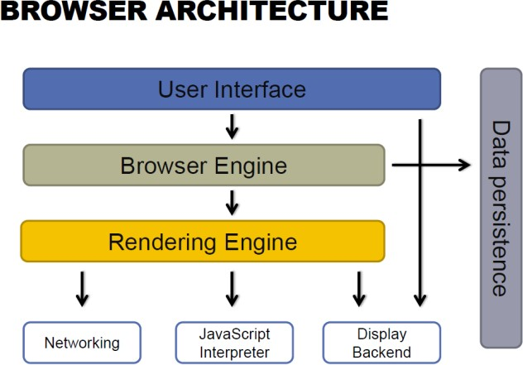

**USER INTERFACE**

The space where interaction between users and the browser. Most of the browsers have common inputs for user interface:

- Address bar.

- Next and back buttons.

- Buttons for home, refresh and stop

- Bookmark web pages

**BROWSER ENGINE**

Browser Engine provides methods to begin the loading of URL and other high-level browsing actions.

- Reload, Back, Forward actions

- Error messages

- Loading progress

**RENDERING ENGINE**

Rendering Engine interprets (render) the HTML, XML, JavaScript and generates the layout that is displayed in the User Interface. Key component of this phase is HTML, CSS parse.

**NETWORKING**

Access and transfer data on the internet (calls HTTP, HTTPS, FTP). The Networking components handles all aspects of internet communication or security.

**JAVASCRIPT INTERPRETER**

Component parse & executes the JavaScript that is embedded in the website. Results of the execution a passed to the Rendering Engines for display.

**DISPLAY BACKEND**

Display common UI components. Drawing basic widgets like combo boxes, windows.

**DATA PERSISTENCE**

Storing the data on the client side.

- Cookies.

- Cache.

## **HTTP Request Headers**

|  |  |  |
| --- | --- | --- |
| **Sr.no** | **Request** | **Explain** |
| 1 | User-Agent | Indicates the user agent (browser or client) making the request. |
| 2 | Host | Specifies the hostname of the server being requested, often used for virtual hosting. |
| 3 | Accept | Informs the server about the types of media the client can process. |
| 4 | Cookie | Informs the server about the types of media the client can process. |
| 5 | Authorization | Includes credentials for accessing restricted resources, often used with Basic authentication. |
| 6 | Referer | Indicates the URL of the page from which the request was initiated. |
| 7 | Content-Type | Specifies the media type of the request content, particularly important for POST requests. |
| 8 | Accept-Language | Informs the server about the preferred language of the client. |
| 9 | User-Agent | User-Agent for a mobile browser. |
| 10 | DNT (Do Not Track) | Requests that the server should not track the user's activity. |

## **HTTP Response Headers**

|  |  |  |
| --- | --- | --- |
| **Sr.no** | **Request** | **Explain** |
| 1 | Content-Type | Specifies the media type and character encoding of the response content. |
| 2 | Content-Length | Indicates the length of the response body in bytes. |
| 3 | Server | Provides information about the web server software being used. |
| 4 | Set-Cookie | Used to set cookies on the client's browser. |
| 5 | Cache-Control | Controls caching behavior in the browser. |
| 6 | Location | Informs the browser about the new location to which it should navigate. |
| 7 | Last-Modified | Indicates the last modification date of the resource. |
| 8 | ETag | Provides a unique identifier for the version of the resource, used in caching. |
| 9 | WWW-Authenticate | Used in responses to indicate authentication required by the server. |
| 10 | Access-Control-Allow-Origin | Indicates which origins are permitted to access the resource via Cross-Origin Resource Sharing (CORS). |

# **Experiment No: 2**

**Aim:** Create your resume using HTML (Suggested sections of resume are Personal Information, Educational Information, Professional Skills, Experience, Achievements, Hobbies), Experiment with text, colors, link and list.

## **Index.html**

<!DOCTYPE html>

<html lang="en">

<head>

    <meta charset="UTF-8">

    <meta name="viewport" content="width=device-width, initial-scale=1.0">

    <title>Resume</title>

</head>

<body>

    <div class="main">

        <h2><b>Resume</b></h2>

        <hr>

        <div class="personal_details">

            <h3><u>Personal Details</u></h3>

            <table>

                <tr>

                    <th>Name</th>

                    <td>Malam Hari</td>

                    <td rowspan="7" id="photo"><img id="photo" src="Photo.jpg"></td>

                </tr>

                <tr>

                    <th>Mobile</th>

                    <td>7284080686</td>

                </tr>

                <tr>

                    <th>Email</th>

                    <td>malamharid@gmail.com</td>

                </tr>

                <tr>

                    <th>Age</th>

                    <td>20</td>

                </tr>

                <tr>

                    <th>Gender</th>

                    <td>Male</td>

                </tr>

                <tr>

                    <th>Birth Date</th>

                    <td>01/09/2003</td>

                </tr>

                <tr>

                    <th>Address</th>

                    <td>Junagadh</td>

                </tr>

            </table>

        </div>

        <br>

        <hr>

        <div class="education_details">

            <h3><u>Education Details</u></h3>

            <table border="1" style="border-collapse: collapse;">

                <tr>

                    <th>Standard</th>

                    <th>Board</th>

                    <th>Year</th>

                    <th>Percentage</th>

                </tr>

                <tr>

                    <td>10<sup>th</sup></td>

                    <td>GSHEB</td>

                    <td>2019</td>

                    <td>77.5</td>

                </tr>

                <tr>

                    <td>12<sup>th</sup></td>

                    <td>GSHEB</td>

                    <td>2021</td>

                    <td>82.5</td>

                </tr>

                <tr>

                    <td>IT (BE)</td>

                    <td>GTU</td>

                    <td>2025</td>

                    <td>9.2</td>

                </tr>

            </table>

        </div>

        <br>

        <hr>

        <div class="skills">

            <h3><u>Skills</u></h3>

            <ul class="tech">

                <li><b>Technical Skills</b></li>

                <ul class="h">

                    <li>HTML</li>

                    <li>CSS</li>

                    <li>Java Script</li>

                    <li>PHP</li>

                    <li>MySQL</li>

                    <li>DBMS</li>

                    <li>Java</li>

                </ul>

                <ul class="h">

                    <li>Python</li>

                    <li>MongoDB</li>

                    <li>MS Office</li>

                    <li>Photoshop</li>

                    <li>Git</li>

                    <li>Github</li>

                </ul>

            </ul>

            <ul class="nontech">

                <li><b>Non Technical Skill</b></li>

                <ul>

                    <li>Communication Skill</li>

                    <li>Other Soft Skills</li>

                </ul>

            </ul>

        </div>

        <br>

        <hr>

        <div class="experience">

            <h3><u>Experience</u></h3>

            <table border="1" style="border-collapse: collapse;">

                <tr>

                    <th>Company</th>

                    <th>Profession</th>

                    <th>Duration</th>

                </tr>

                <tr>

                    <td>TCS</td>

                    <td>Java intern</td>

                    <td>6 month</td>

                </tr>

                <tr>

                    <td>Google</td>

                    <td>Junior Java Developer</td>

                    <td>1 year</td>

                </tr>

            </table>

        </div>

        <br>

        <hr>

        <div class="declaration">

            <h3><u>Declaration</u></h3>

                <p>I herreby declare that the details and information given above are

                    compelete and true to the best of my knowledge</p>

                <img src="Sing.jpg" height="50px" width="160px" alt="">

        </div>

    </div>

</body>

</html>

## **Output**

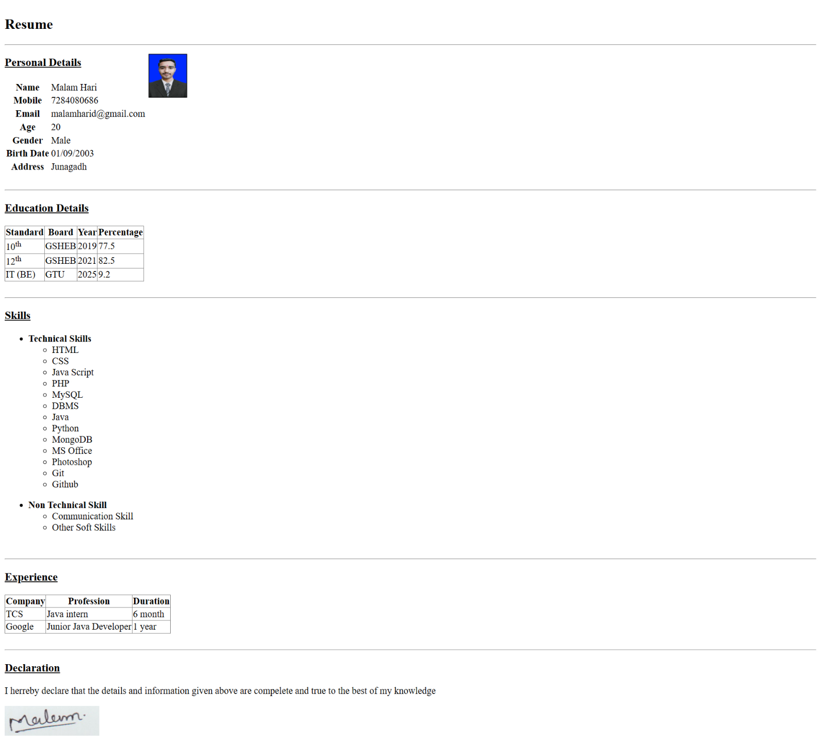

## **Quiz:**

1. **Explain HTML Document Structure.**

HTML (Hypertext Markup Language) is the standard language used to create web pages. An HTML document consists of a structured set of elements that define the content and its presentation on a web page.

Here is a basic structure of an HTML document:

<!DOCTYPE html>: This declaration specifies the document type and version of HTML (HTML5 in this case).

<!DOCTYPE html>

<html>

<head>

    <meta charset="UTF-8">

    <title>Document Title</title>

</head>

<body>

    <!-- Content goes here -->

</body>

</html>

<html>: The root element that encloses all the content on the web page.

<head>: Contains meta-information about the document, such as the character encoding and the page title.

<meta charset="UTF-8">: Specifies the character encoding for the document (UTF-8 is widely used for international character support).

<title>: Sets the title of the web page, which is displayed in the browser's title bar or tab.

<body>: Contains the main content of the web page, including text, images, links, and other elements.

1. **List and explain any five HTML formatting tags.**

HTML provides various formatting tags to control the appearance of text and elements on a web page.

Here are five commonly used formatting tags:

<b>: The <b> tag is used to make text bold. For example: <b>This text is bold</b>.

<i>: The <i> tag is used to make text italic. For example: <i>This text is italic</i>.

<u>: The <u> tag is used to underline text. For example: <u>This text is underlined</u>.

<em>: The <em> tag is used to emphasize text, typically rendering it in italics.

For example: <em>This text is emphasized</em>.

<strong>: The <strong> tag is used to indicate strong importance or emphasis, typically rendering it in

bold. For example: <strong>This text is strongly emphasized</strong>.

1. **Explain ordered and unordered list with example.**

HTML provides two types of lists: ordered lists and unordered lists.

**Ordered List (<ol>):** An ordered list is a list of items that are numbered or lettered in a specific order. Each list item is defined using the <li> (list item) tag.

Here's an example:

<ol>

    <li>Item 1</li>

    <li>Item 2</li>

    <li>Item 3</li>

</ol>

**Unordered List (<ul>):** An unordered list is a list of items that are typically displayed with bullet points. Like ordered lists, each list item is defined using the <li> tag.

Here's an example:

<ul>

    <li>Item A</li>

    <li>Item B</li>

    <li>Item C</li>

</ul>

# **Experiment No: 3**

**Aim:** Create your class time table using table tag, experiment with rowspan, colspan, cellspacing and cellpadding attributes.

<!DOCTYPE html>

<html lang="en">

<head>

    <meta charset="UTF-8">

    <meta name="viewport" content="width=device-width, initial-scale=1.0">

    <title>Time Table</title>

</head>

<body>

    <table border="1" style="border-collapse: collapse;">

        <tr>

            <th colspan="8" class="head">GOVERNMENT ENGINEERING COLLEGE MODASA</th>

        </tr>

        <tr>

            <th colspan="8" class="fontsize1">CE/IT DEPARTMENT</th>

        </tr>

        <tr>

            <th colspan="8" class="fontsize2">CLASS TIME TABLE</th>

        </tr>

        <tr>

            <th class="no"></th>

            <th>TIME</th>

            <th>MON</th>

            <th>TUE</th>

            <th>WED</th>

            <th>THU</th>

            <th>FRI</th>

            <th class="sat">SAT</th>

        </tr>

        <tr>

            <th>1</th>

            <th>10:55 TO 11:55</th>

            <td>WD(3151606)-HRP-8209</td>

            <td rowspan="2">

                A1 DE-IIA(3150001)-VRP- <br>8213<br>

                A2 ADA(3150703)-NA- <br>8215<br>

                A3 CN(3150710)-AAP- <br>8216<br>

                A4 WD(3151606)-HRP- <br>8217<br>

            </td>

            <td rowspan="2">

                A1 DSC(3151608)-NNM- <br>8213<br>

                A2 DE-IIA(3150001)-NA- <br>8213<br>

                A3 ADA(3150703)-RJP- <br>8213<br>

                A4 CN(3150710)-NA- <br>8215<br>

            </td>

## **Index.html**

            <td rowspan="2">

                A1 WD(3151606)-HRP- <br>8213<br>

                A2 DSC(3151608)-NNM- <br>8215<br>

                A3 DE-IIA(3150001)-NA- <br>8216<br>

                A4 ADA(3150703)-RJP- <br>8217<br>

            </td>

            <td>IPDC(3150005)-ABP- 8209</td>

            <td></td>

        </tr>

        <tr>

            <th>2</th>

            <th>11:55 TO 12:55</th>

            <td>DSC(3151608)-VRP-8209</td>

            <td>IPDC(3150005)-NA-8209</td>

            <td></td>

        </tr>

        <tr>

            <th>3</th>

            <th>13:20 TO 14:20</th>

            <td rowspan="2">

                A1 ADA(3150703)-RJP- <br>8213<br>

                A2 CN(3150710)-AAP- <br>8215<br>

                A3 WD(3151606)-HRP- <br>8216<br>

                A4 DSC(3151608)-NNM- <br>8217<br>

            </td>

            <td>WD(3151606)-HRP-8209</td>

            <td>CN(3150710)-AAP-8209</td>

            <td>WD(3151606)-VAR-8209</td>

            <td></td>

            <td></td>

        </tr>

        <tr>

            <th>4</th>

            <th>14:20 TO 15:20</th>

            <td>ADA(3150703)-RJP-8209</td>

            <td>ADA(3150703)-SGP-8209</td>

            <td>ADA(3150703)-SGP-8209</td>

            <td>CN(3150710)-AAP-8209</td>

            <td></td>

        </tr>

        <tr>

            <th>5</th>

            <th>15:30 TO 16:30</th>

            <td>ADA(3150703)-RJP-8209</td>

            <td>CN(3150710)-PSM-8209</td>

            <td>PE(3150709)-URB-8209</td>

            <td>DSC(3151608)-NNM- 8209</td>

            <td rowspan="2">

                A1 CN(3150710)-AAP- <br>8213<br>

                A2 WD(3151606)-HRP- <br>8213<br>

                A3 DSC(3151608)-NNM- <br>8215<br>

                A4 DE-IIA(3150001)-NA- <br>8216<br>

            </td>

## **Output**

            <td></td>

        </tr>

        <tr>

            <th>6</th>

            <th>116:30 TO 17:30</th>

            <td>CN(3150710)-PSM-8209</td>

            <td>PE(3150709)-ABP-8209</td>

            <td>PE(3150709)-NA-8209</td>

            <td></td>

            <td></td>

        </tr>

    </table>

</body>

</html>

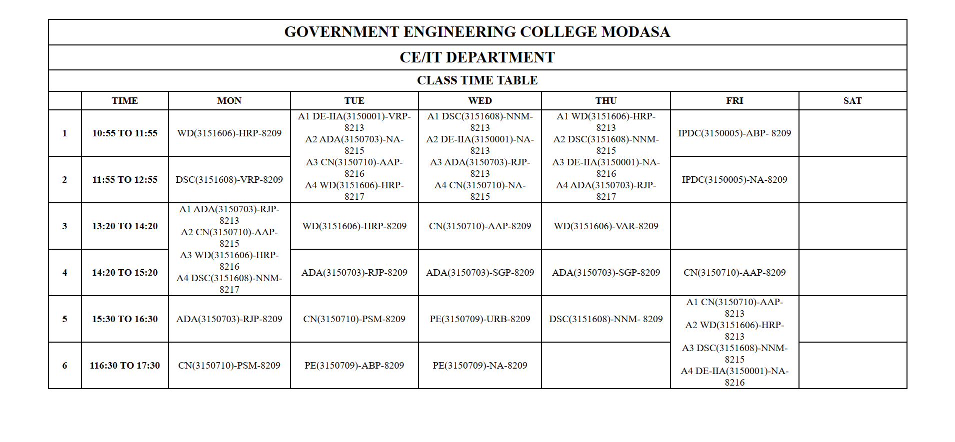

## **Quiz:**

1. **Explain the use of rowspan and colspan attributes in table tag.**

**rowspan Attribute:** This attribute is used to specify how many rows a table cell should span vertically. It is typically applied to a <td> (table data) or <th> (table header) element within a table.

**colspan Attribute:** This attribute is used to specify how many columns a table cell should span horizontally. Like rowspan, it is typically applied to a <td> or <th> element.

1. **Differentiate between <td> and <th>.**

**<td> (Table Data):**

<td> is used to define regular data cells within an HTML table.

It is used to represent the actual data or content of the table.

<td> cells are typically styled with regular font and do not have any special formatting by default.

They are used within the <tr> (table row) element.

**<th> (Table Header):**

<th> is used to define header cells within an HTML table.

It is used to represent column or row headers, providing context or labels for the data in the table.

<th> cells are typically displayed in bold and centered by default, making them stand out as headers.

They are used within the <tr> element that defines the table header, usually located at the beginning of the table within a <thead> section.

# **Experiment No: 4**

**Aim:** Design static web pages for your college containing a description of the courses, departments, faculties, library etc. Provide links for navigation among pages.

## **Index.html**

<!DOCTYPE html>

<html lang="en">

<head>

    <meta charset="UTF-8">

    <meta name="viewport" content="width=device-width, initial-scale=1.0">

    <title>College Website</title>

</head>

<body>

    <div>

        <nav>

            <ul style="display: flex; justify-content: space-evenly;">

                <li><a href="../07 Collage Web/home.html" target="target">

                        HOME

                    </a></li>

                <li><a href="../07 Collage Web/subjects.html" target="target">

                        SUBJECTS

                    </a></li>

                <li><a href="../07 Collage Web/faculties.html" target="target">

                        FACULTIES

                    </a></li>

                <li><a href="../07 Collage Web/facilities.html" target="target">

                        FACILITIES

                    </a></li>

            </ul>

        </nav>

    </div>

    <div style="height: 100vh;">

        <iframe name="target" width="100%" height="100%"></iframe>

    </div>

</body>

</html>

## **Output**

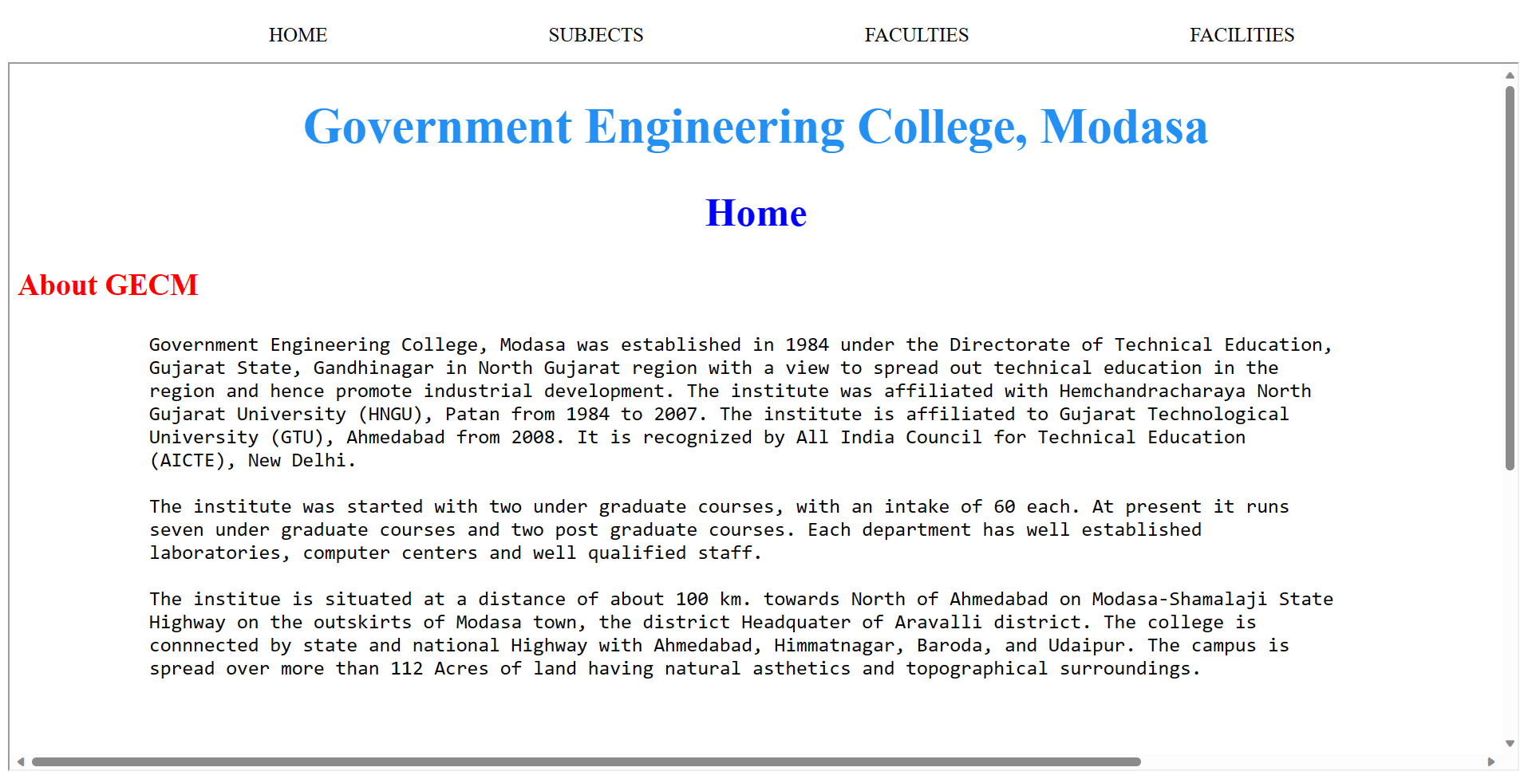

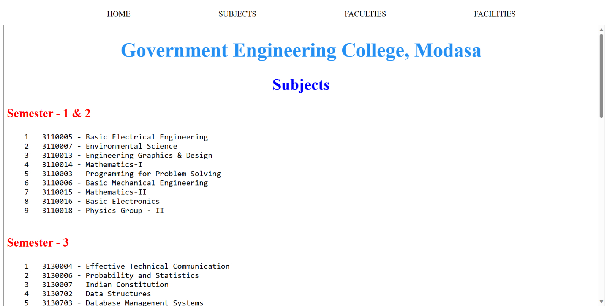

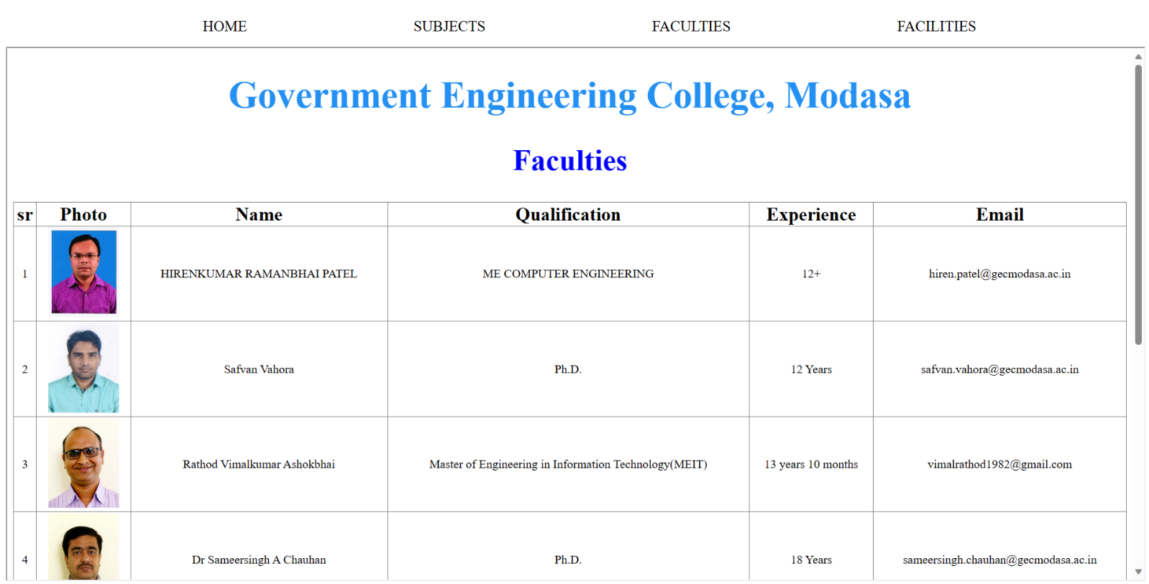

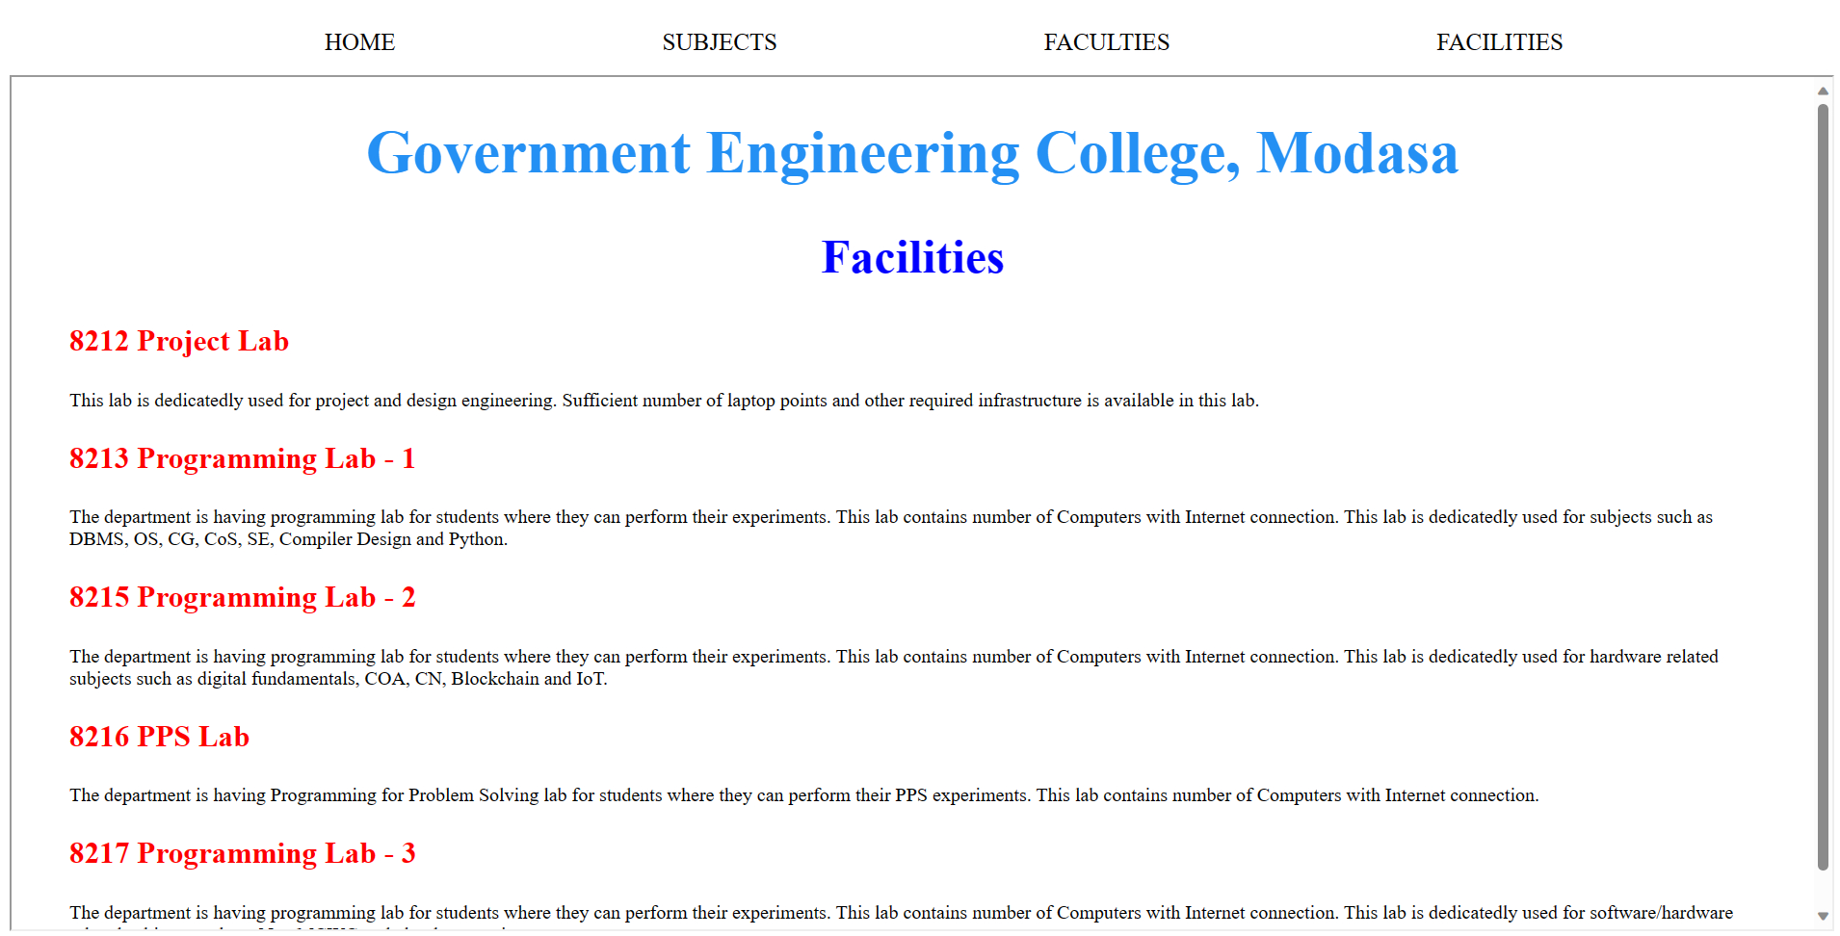

## **Quiz:**

1. **Explain HTML Link target attribute.**

In HTML, the target attribute is used to specify how a linked resource (such as a hyperlink or anchor <a> element) should be displayed when clicked by the user. It determines where the linked content will open.

The target attribute accepts several values, each specifying a different behavior:

**_blank:** Opens the linked resource in a new, unnamed browser window or tab.

**_self:** Opens the linked resource in the same window or frame where the link was clicked

(The default behavior if no target attribute is specified).

**_parent:** Opens the linked resource in the parent window or frame of the current frame, if applicable.

**_top:** Opens the linked resource in the top-level browsing context, replacing all frames if the current document is part of a frameset.

**<frame_name>:** Opens the linked resource in a specific named frame or iframe. Replace <frame_name> with the name of the target frame or iframe.

Here's an example of how to use the target attribute in an anchor element (<a>) to open a link in a new tab or window:

<a href="https://www.example.com" target="_blank">Visit Example.com</a>

1. **How to use image as a link ?**

To use an image as a link in HTML, you can wrap an <img> (image) element inside an <a> (anchor) element. This allows users to click the image to navigate to another web page or resource.

Here's the basic structure:

<a href="https://www.example.com">

    <img src="image.jpg" alt="Image Description">

</a>

<a>: The anchor element defines the link and specifies the href attribute, which contains the URL to the destination page or resource.

<img>: The image element is nested inside the anchor element. It defines the image to be displayed and includes the src attribute, which points to the image file, and the alt attribute, which provides alternative text for the image (useful for accessibility).

# **Experiment No: 5**

**Aim:** Create User Registration Form in HTML (Suggested to use fields like Name, Date of Birth, Gender, Email Id, Mobile No.,Address, State , Education , Image Upload etc) using textbox, textarea, checkbox, radio button, select box, button, file upload etc.

## **Index.html**

<!DOCTYPE html>

<html lang="en">

<head>

    <title>Registration Form</title>

</head>

<body>

    <h1>Registration Form</h1>

        <form name="Registration" id="form">

            <table style="text-align: left;">

                <tr>

                    <th><label for="name">Name</label></th>

                    <td><input type="text" id="name"></td>

                </tr>

                <tr>

                    <th><label for="email">Email</label></th>

                    <td><input type="email" id="email"></td>

                </tr>

                <tr>

                    <th><label for="dob">Date of Birth</label></th>

                    <td><input type="date" id="dob"></td>

                </tr>

                <tr>

                    <th><label for="number">Mobile No.</label></th>

                    <td><input type="number" id="number"></td>

                </tr>

                <tr>

                    <th>Gender</th>

                    <td>

                        <input type="radio" id="male" name="gender">

                        <label for="male">Male</label>

                        <input type="radio" id="female" name="gender">

                        <label for="female">Female</label>

                        <input type="radio" id="other" name="gender">

                        <label for="other">Other</label>

                    </td>

                </tr>

                <tr>

                    <th><label for="states">States</label></th>

                    <td><select name="states" id="states">

                            <option value="Options">Select State</option>

                            <option value="Gujarat">Gujarat</option>

                            <option value="up">Uttar Pradesh</option>

                            <option value="Maharashtra">Maharashtra</option>

                            <option value="mp">Madhya pradesh</option>

                            <option value="keral">Keral</option>

                            <option value="delhi">delhi</option>

                            <option value="other">Other</option>

                        </select></td>

                </tr>

                <tr>

                    <th><label for="address">Address</label></th>

                    <td><textarea name="" id="address" cols="30" rows="3"></textarea>

</td>

                </tr>

                <tr>

                    <th>Education</th>

                    <td>

                        <input type="radio" id="10th" name="education">

                        <label for="10th">10<sup>th</sup></label>

                        <input type="radio" id="12th" name="education">

                        <label for="12th">12<sup>th</sup></label>

                        <input type="radio" id="graduate" name="education">

                        <label for="graduate">Graduate</label>

                    </td>

                </tr>

                <tr>

                    <th>Hobies</th>

                    <td>

                        <input type="checkbox" id="acting">

                        <label for="acting">Acting</label>

                        <input type="checkbox" id="Photography">

                        <label for="Photography">Photography</label>

                        <input type="checkbox" id="reading">

                        <label for="reading">Reading</label>

                        <input type="checkbox" id="Dancing">

                        <label for="Dancing">Dancing</label>

                    </td>

                </tr>

                <tr><th><label for="marksheet">Marksheet</label></th>

                    <td><input type="file" id="marksheet"></td></tr>

                <tr><th><label for="lc">LC</label></th>

                    <td><input type="file" id="lc"></td></tr>

                <tr>

                    <th><label for="photo">Photo</label></th>

                    <td><input type="file" id="photo"></td>

                </tr>

                <tr>

                    <th><input type="submit"></th>

                    <td><input type="reset"></td>

                </tr>

            </table>

        </form>

</body>

</html>

## **Output**

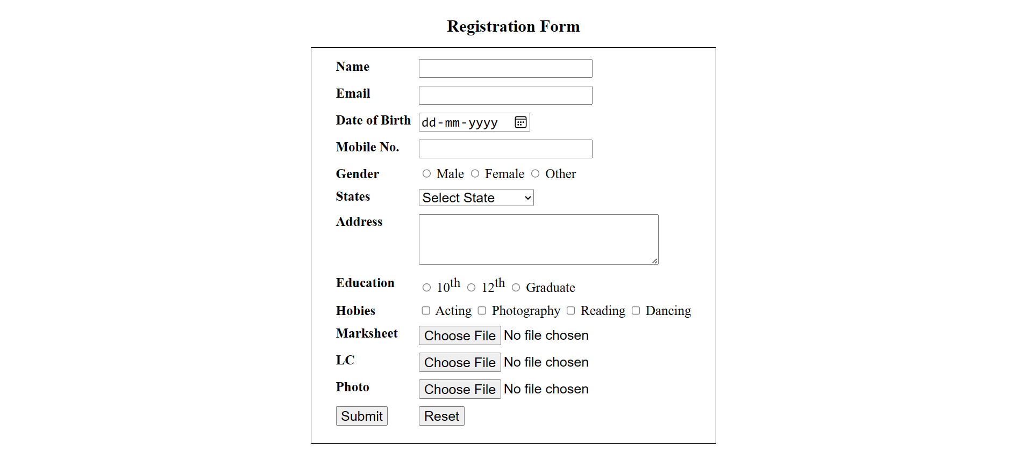

## **Quiz:**

1. **Explain form tag with its attributes.**

In HTML, the <form> element is used to create interactive forms that allow users to input data and submit it to a server for processing. The <form> element can have various attributes that control its behavior:

**action:** Specifies the URL to which the form data should be submitted when the user submits the form. For example: <form action="submit.php">.

**method:** Specifies the HTTP method to be used when submitting the form data. The two most common values are "GET" and "POST." "GET" appends data to the URL, while "POST" sends data in the request body. For example: <form method="post">.

**target:** Specifies where the response from the server should be displayed. Common values include "_blank" (in a new window or tab), "_self" (in the same window or frame), "_parent" (in the parent frame), or "_top" (in the top-level window or frame).

**name:** Assigns a name to the form, which can be used to reference the form in JavaScript or to group form elements.

**enctype:** Specifies the encoding type used when sending data to the server. Common values include "application/x-www-form-urlencoded" (default, for sending form data as key-value pairs) and "multipart/form-data" (used for file uploads).

**autocomplete:** Controls whether the browser should automatically complete form fields based on the user's input history. Values can be "on" or "off."

**novalidate:** If present, this attribute prevents the browser from validating form inputs before submission. It's useful for disabling browser-based form validation.

Here's an example of a simple form with some of these attributes:

<form action="submit.php" method="post" target="_blank" name="myForm" enctype="multipart/form-data" autocomplete="off" novalidate>

    <!-- Form elements go here -->

</form>

1. **Differentiate between text input and password input controls.**

**Text Input (<input type="text">):**

Text input controls are used for accepting single-line text input from users.

They are created using the <input> element with the type attribute set to "text."

The text entered into a text input field is visible to the user.

Example: <input type="text" name="username">.

**Password Input (<input type="password">):**

Password input controls are used for entering sensitive information like passwords or PINs.

They are created using the <input> element with the type attribute set to "password."

The text entered into a password input field is typically masked (e.g., with asterisks) to hide it from view for security reasons.

Example: <input type="password" name="password">.

Here's a side-by-side comparison:

<!-- Text Input -->

<label for="username">Username:</label>

<input type="text" id="username" name="username">

<!-- Password Input -->

<label for="password">Password:</label>

<input type="password" id="password" name="password">

1. **Explain various types of buttons available in HTML.**

HTML provides several types of buttons that you can use within forms or elsewhere in your web page:

**<input type="submit">:** This type of button is used to submit a form. When clicked, it sends the form data to the server specified in the form's action attribute.

**<input type="reset">:** This button resets the form fields to their initial values, as specified in the HTML.

**<input type="button">:** This is a generic button that can be used to trigger JavaScript functions or other client-side actions. It doesn't have a default behavior.

**<button>:** The <button> element allows you to create customizable buttons with text or other content inside them. You can use JavaScript to define custom actions when this button is clicked.

**<input type="image">:** This type of button is represented as an image. It submits the form when the user clicks on the image at the specified coordinates (useful for image maps).

# **Experiment No: 6**

**Aim:** Create two web pages, one contains audios and other page contains videos (using HTML5 audio and video tags). Also provide link for navigation between pages.

## **video.html**

<!DOCTYPE html>

<html lang="en">

<head>

    <meta charset="UTF-8">

    <meta name="viewport" content="width=device-width, initial-scale=1.0">

    <title>Video</title>

</head>

<body>

    <div>

        <video controls width="40%" height="">

            <source src="assets/video (2160p).mp4" type="video/mp4">

        </video> <br> <br>

        <a href="audio.html">Click Here For Audio File</a>

    </div>

</body>

</html>

## **audio.html**

<!DOCTYPE html>

<html lang="en">

<head>

    <meta charset="UTF-8">

    <meta name="viewport" content="width=device-width, initial-scale=1.0">

    <title>Audio</title>

</head>

<body>

    <audio controls>

        <source src="assets/Shree_Hanuman_Chalisa.mp3" type="audio/mp3">

    </audio>

    <br><br>

    <a href="index.html">Click Here For Video File</a>

</body>

</html>

## **Output**

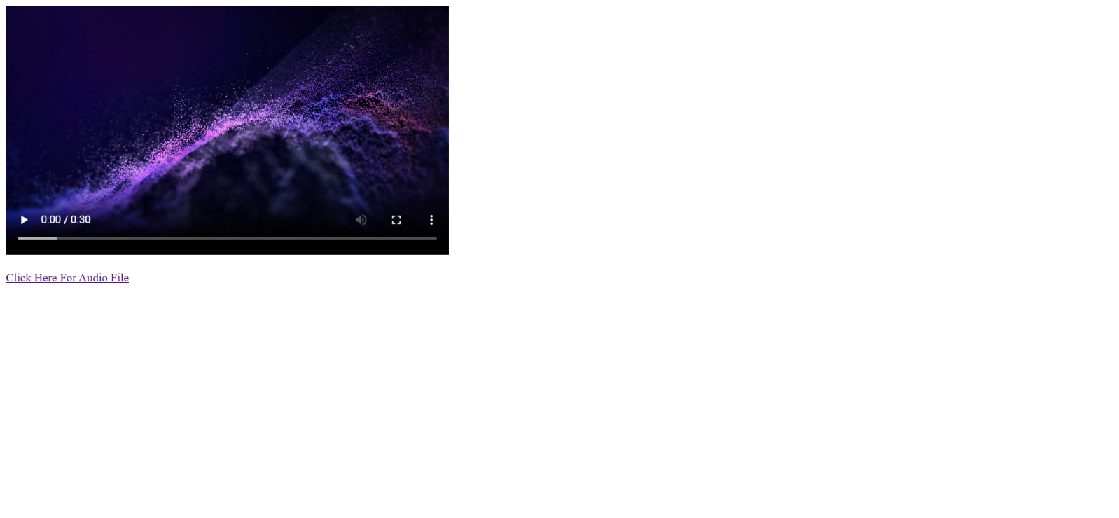

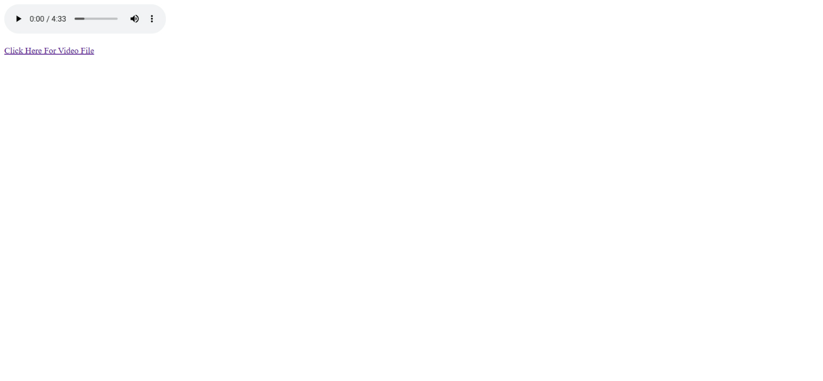

## **Quiz:**

1. **Explain audio and video tags.**
2. **<audio> Element:**

The <audio> element is used to embed audio content, such as music, sound effects, or podcasts, into a web page. It supports various audio formats, including MP3, WAV, and Ogg Vorbis.

<audio controls>

    <source src="audio.mp3" type="audio/mpeg">

    Your browser does not support the audio element.

</audio>

Here's the basic structure of the <audio> element:

* **controls:** The controls attribute adds audio playback controls (play, pause, volume, etc.) to the audio element, allowing users to interact with the audio.
* **<source>:** Inside the <audio> element, you can include one or more <source> elements to specify different audio sources in various formats. The browser will choose the first supported format listed.
* **src:** The src attribute within the <source> element specifies the path to the audio file.
* **type:** The type attribute specifies the MIME type of the audio file. This helps the browser determine which format to use.
* The text within the <audio> element (in this case, "Your browser does not support the audio element") is displayed if the browser doesn't support the <audio> element or any of the specified formats.

1. **<video> Element:**

The <video> element is used to embed video content into a web page. It supports various video formats like MP4, WebM, and Ogg Theora.

Here's the basic structure of the <video> element:

<video controls width="400" height="300">

<source src="video.mp4" type="video/mp4">

Your browser does not support the video element.

</video>

* **controls:** Similar to the <audio> element, the controls attribute adds video playback controls to the <video> element.
* **width and height:** These attributes specify the width and height of the video player on the web page.
* **<source>:** Like the <audio> element, you can use one or more <source> elements inside the <video> element to specify different video sources in various formats.
* src and type attributes within the <source> elements serve the same purposes as described earlier for the <audio> element.
* The text inside the <video> element is displayed if the browser doesn't support the <video> element or any of the specified video formats.
* The <video> element can also include additional attributes and features for more advanced video control and customization, such as poster images, subtitles, and more.

# **Experiment No: 7**

**Aim:** Create a web page using frame. Divide the page into two parts with Navigation links on left hand side of page (width=20%) and content page on right hand side of page (width = 80%). On clicking the navigation Links corresponding content must be shown on the right-hand side.

## **index.html**

<title>College Web</title>

<frameset cols="20%, 80%">

    <frame src="links.html" />

    <frame name="target1" />

</frameset>

## **links.html**

<!DOCTYPE html>

<html lang="en">

<head>

    <meta charset="UTF-8">

    <meta name="viewport" content="width=device-width, initial-scale=1.0">

    <title>Document</title>

</head>

<style>

    li {

        font-size: 40px;

        list-style-type: none;

        padding-bottom: 40px;

    }

    a {

        color: black;

        text-decoration: none;

    }

</style>

<body>

    <ul>

        <li><a href="home.html" target="target1">Home</a></li>

        <li><a href="subjects.html" target="target1">Subjects</a></li>

        <li><a href="faculties.html" target="target1">Faculties</a></li>

        <li><a href="facilities.html" target="target1">Facilities</a></li>

    </ul>

</body>

</html>

## **home.html**

<!DOCTYPE html>

<html lang="en">

<head>

    <meta charset="UTF-8">

    <meta name="viewport" content="width=device-width, initial-scale=1.0">

    <title>Document</title>

</head>

<body>

    <center>

        <h1 style="font-size: 50px; color: rgb(36, 144, 244);">

Government Engineering College, Modasa</h1>

        <h2 style="font-size: 40px; color: blue;">Home</h2>

    </center>

    <div>

        <h3 style="font-size: 30px; color: red;">About GECM</h3>

        <p>

            <pre style="font-size: 20px">

Government Engineering College, Modasa was established in 1984 under the Directorate of Technical Education,Gujarat State, Gandhinagar in North Gujarat region with a view to spread out technical education in the region and hence promote industrial development. The institute was affiliated with Hemchandracharaya North Gujarat University (HNGU), Patan from 1984 to 2007. The institute is affiliated to Gujarat Technological University (GTU), Ahmedabad from 2008. It is recognized by All India Council for Technical Education (AICTE), New Delhi.

The institute was started with two under graduate courses, with an intake of 60 each. At present it runs seven under graduate courses and two post graduate courses. Each department has well established laboratories, computer centers and well qualified staff.

The institue is situated at a distance of about 100 km. towards North of Ahmedabad on Modasa-Shamalaji State Highway on the outskirts of Modasa town, the district Headquater of Aravalli district. The college is connnected by state and national Highway with Ahmedabad, Himmatnagar, Baroda, and Udaipur. The campus is spread over more than 112 Acres of land having natural asthetics and topographical surroundings.

        </pre>

        </p>

        <br>

    </div>

    </div>

        <h3 style="font-size: 30px; color: red;">Notice Board</h3>

        <p>

        <pre style="font-size: 20px">

            Boys Hostel Admission Merit list-2 for 1st Year Students August 2023

            “Girls Hostel Admission Merit list-2 for 1st Year Students August 2023

## **subjects.html**

            “Meri Maaati Mera Desh” Campaingn : August 2023

            Merit list of Girls Hostel (1st Year Students) : August 2023

            Merit list of Boys Hostel (1st Year Students) : August 2023

            Notice of Marksheet collection 02-08-2023

            Instructions for newly admitted students at GEC Modasa 2023-24

Students from the CE/IT department published two Indian patents and received a grant of Rs 1.00 lakh from the SSIP Cell as part of the SSIP 2.0 policy in April 2023.

            </pre>

        </p>

</body>

</html>

<!DOCTYPE html>

<html lang="en">

<head>

    <meta charset="UTF-8">

    <meta name="viewport" content="width=device-width, initial-scale=1.0">

    <title>Document</title>

</head>

<body>

    <center>

        <h1 style="font-size: 50px; color: rgb(36, 144, 244);">

            Government Engineering College, Modasa</h1>

        <h2 style="font-size: 40px; color: blue;">Subjects</h2>

    </center>

    <section>

        <h3 style="font-size: 30px; color: red;">Semester - 1 & 2</h3>

        <p>

        <pre style="font-size: 20px">

    1   3110005 - Basic Electrical Engineering

    2   3110007 - Environmental Science

    3   3110013 - Engineering Graphics & Design

    4   3110014 - Mathematics-I

    5   3110003 - Programming for Problem Solving

    6   3110006 - Basic Mechanical Engineering

    7   3110015 - Mathematics-II

    8   3110016 - Basic Electronics

    9   3110018 - Physics Group - II

                </pre>

        </p>

    </section>

    <section>

        <h3 style="font-size: 30px; color: red;">Semester - 3</h3>

        <p>

        <pre style="font-size: 20px">

    1   3130004 - Effective Technical Communication

    2   3130006 - Probability and Statistics

    3   3130007 - Indian Constitution

    4   3130702 - Data Structures

    5   3130703 - Database Management Systems

    6   3130704 - Digital Fundamentals

             </pre>

        </p>

    </section>

    <section>

        <h3 style="font-size: 30px; color: red;">Semester - 4</h3>

        <p>

        <pre style="font-size: 20px">

    1   2140705 - Object Oriented Programming With C++

    2   3140702 - Operating System

    3   3140705 - Object Oriented Programming - I

    4   3140707 - Computer Organization & Architecture

    5   3140708 - Discrete Mathematics

    6   3140709 - Principles Of Economics And Management

             </pre>

        </p>

    </section>

    <section>

        <h3 style="font-size: 30px; color: red;">Semester - 5</h3>

        <p>

        <pre style="font-size: 20px">

    1   3150703 - Analysis And Design Of Algorithms

    2   3150709 - Professional Ethics

    3   3150710 - Computer Networks

    4   3150711 - Software Engineering

    5   3150712 - Computer Graphics

    6   3150713 - Python for Data Science

    7   3150714 - Cyber Security

             </pre>

        </p>

    </section>

    <section>

        <h3 style="font-size: 30px; color: red;">Semester - 6</h3>

        <p>

        <pre style="font-size: 20px">

    1   2160704 - Theory of Computation

    2   2160707 - Advanced Java

    3   2160708 - Web Technology

    4   3160704 - Theory of Computation

    5   3160707 - Advance java Programming

    6   3160712 - Microprocessor and Interfacing

## **faculties.html**

    7   3160713 - WEB Programming

    8   3160714 - Data Mining

    9   3160716 - IOT and Applications

             </pre>

        </p>

    </section>

    <section>

        <h3 style="font-size: 30px; color: red;">Semester - 7</h3>

        <p>

        <pre style="font-size: 20px">

    1   2170701 - Complier Design

    2   2170709 - Information and Network Security

    3   2170710 - Mobile Computing and Wireless Communication

    4   2170715 - Data Mining and Business Intelligence

    5   3170701 - Compiler Design

    6   3170710 - Mobile Computing and Wireless communication

    7   3170716 - Artificial Intelligence

    8   3170719 - Distributed System

    9   3170722 - Big Data Analytics

    10  3170726 - Mobile Application Development

             </pre>

        </p>

    </section>

    <section>

        <h3 style="font-size: 30px; color: red;">Semester - 8</h3>

        <p>

        <pre style="font-size: 20px">

    1   2180703 - Artificial Intelligence

    2   2180712 - Cloud Infrastructure and Services

    3   2180713 - Web Data Management

    4   2180714 - iOS Programming

    5   2180715 - Android Programming

             </pre>

        </p>

    </section>

</body>

</html>

**subjexts.html**

<!DOCTYPE html>

<html lang="en">

<head>

    <meta charset="UTF-8">

    <meta name="viewport" content="width=device-width, initial-scale=1.0">

    <title>Document</title>

    </style>

</head>

<body>

    <center>

        <h1 style="font-size: 50px; color: rgb(36, 144, 244);">

Government Engineering College, Modasa</h1>

        <h2 style="font-size: 40px; color: blue;">Faculties</h2>

    </center>

    <table border="1" width="100%"  style="border-collapse: collapse;" >

        <tr align="center" style="font-size: 25px;">

            <th>sr</th>

            <th >Photo</th>

            <th>Name</th>

            <th>Qualification</th>

            <th>Experience</th>

            <th>Email</th>

        </tr>

        <tr align="center">

            <td>1</td>

            <td><img src="photos/HRP.jpg" alt=""></td>

            <td>HIRENKUMAR RAMANBHAI PATEL</td>

            <td>ME COMPUTER ENGINEERING</td>

            <td>12+</td>

            <td>hiren.patel@gecmodasa.ac.in</td>

        </tr>

        <tr align="center">

            <td>2</td>

            <td><img src="photos/sav.png" alt=""></td>

            <td>Safvan Vahora</td>

            <td>Ph.D.</td>

            <td>12 Years</td>

            <td>safvan.vahora@gecmodasa.ac.in</td>

        </tr>

        <tr align="center">

            <td>3</td>

            <td><img src="photos/VAR.jpg" alt=""></td>

            <td>Rathod Vimalkumar Ashokbhai</td>

            <td>Master of Engineering in Information Technology(MEIT)</td>

            <td>13 years 10 months</td>

            <td>vimalrathod1982@gmail.com</td>

        </tr>

        <tr align="center">

            <td>4</td>

            <td><img src="photos/SAC.jpg" alt=""></td>

            <td>Dr Sameersingh A Chauhan</td>

            <td>Ph.D.</td>

            <td>18 Years</td>

            <td>sameersingh.chauhan@gecmodasa.ac.in</td>

        </tr>

        <tr align="center">

            <td>5</td>

            <td><img src="photos/it_Nilesh.jpg" alt=""></td>

            <td>Dr. Nilesh N. Maltare</td>

            <td>Ph.D.</td>

## **facilities.html**

            <td>14 years</td>

            <td>nilesh.maltare@gecmodasa.ac.in</td>

        </tr>

        <tr align="center">

            <td>6</td>

            <td><img src="photos/it_ac.jpg" alt=""></td>

            <td>Avinash D. Chaudhari</td>

            <td>M.E (Information Technology)</td>

            <td>4 Years</td>

            <td>avinash.chaudhari@gecmodasa.ac.in</td>

        </tr>

        <tr align="center">

            <td>7</td>

            <td><img src="photos/it_psm.jpg" alt=""></td>

            <td>Prashant Sureshbhai Modi</td>

            <td>M.Tech CSE</td>

            <td>15 Years</td>

            <td>prashant7modi7it@gmail.com</td>

        </tr>

        <tr align="center">

            <td>8</td>

            <td><img src="photos/it_anilprajapati.jpg" alt=""></td>

            <td>Anil Prajapati</td>

            <td>M.E-CSE</td>

            <td>12 years</td>

            <td>anil.apit18@gmail.com</td>

        </tr>

    </table>

</body>

</html>

**Output**

<!DOCTYPE html>

<html lang="en">

<head>

    <meta charset="UTF-8">

    <meta name="viewport" content="width=device-width, initial-scale=1.0">

    <title>Document</title>

</head>

<body>

    <center>

        <h1>Government Engineering College, Modasa</h1>

        <h2>Facilities</h2>

    </center>

    <div class="container">

        <h3>8212 Project Lab</h3>

        <p>

            This lab is dedicatedly used for project and design engineering. Sufficient

number of laptop points and other required infrastructure is available in this lab.

        </p>

        <h3> 8213 Programming Lab - 1</h3>

        <p>

            The department is having programming lab for students where they can

perform their experiments. This lab contains number of Computers with Internet connection. This lab is dedicatedly used for subjects such as DBMS, OS, CG, CoS, SE, Compiler Design and Python.

        </p>

        <h3>8215 Programming Lab - 2</h3>

        <p>

            The department is having programming lab for students where they can

perform their experiments. This lab contains number of Computers with

Internet connection. This lab is dedicatedly used for hardware related

            subjects such as digital fundamentals, COA, CN, Blockchain and IoT.</p>

        <h3> 8216 PPS Lab</h3>

        <p>

            The department is having Programming for Problem Solving lab for students

where they can perform their PPS experiments. This lab contains number of

Computers with Internet connection.

        </p>

        <h3>8217 Programming Lab - 3</h3>

        <p>

            The department is having programming lab for students where they can

perform their experiments. This lab contains number of Computers with

Internet connection. This lab is dedicatedly used for software/hardware

            related subjects such as .Net, MCWC and cloud computing.

        </p>

    </div>

</body>

</html>

## **Output**

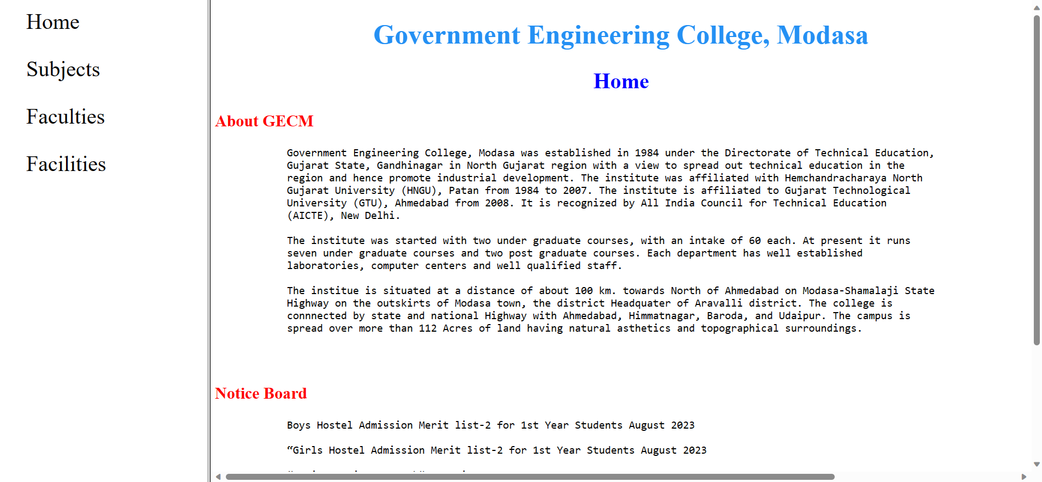

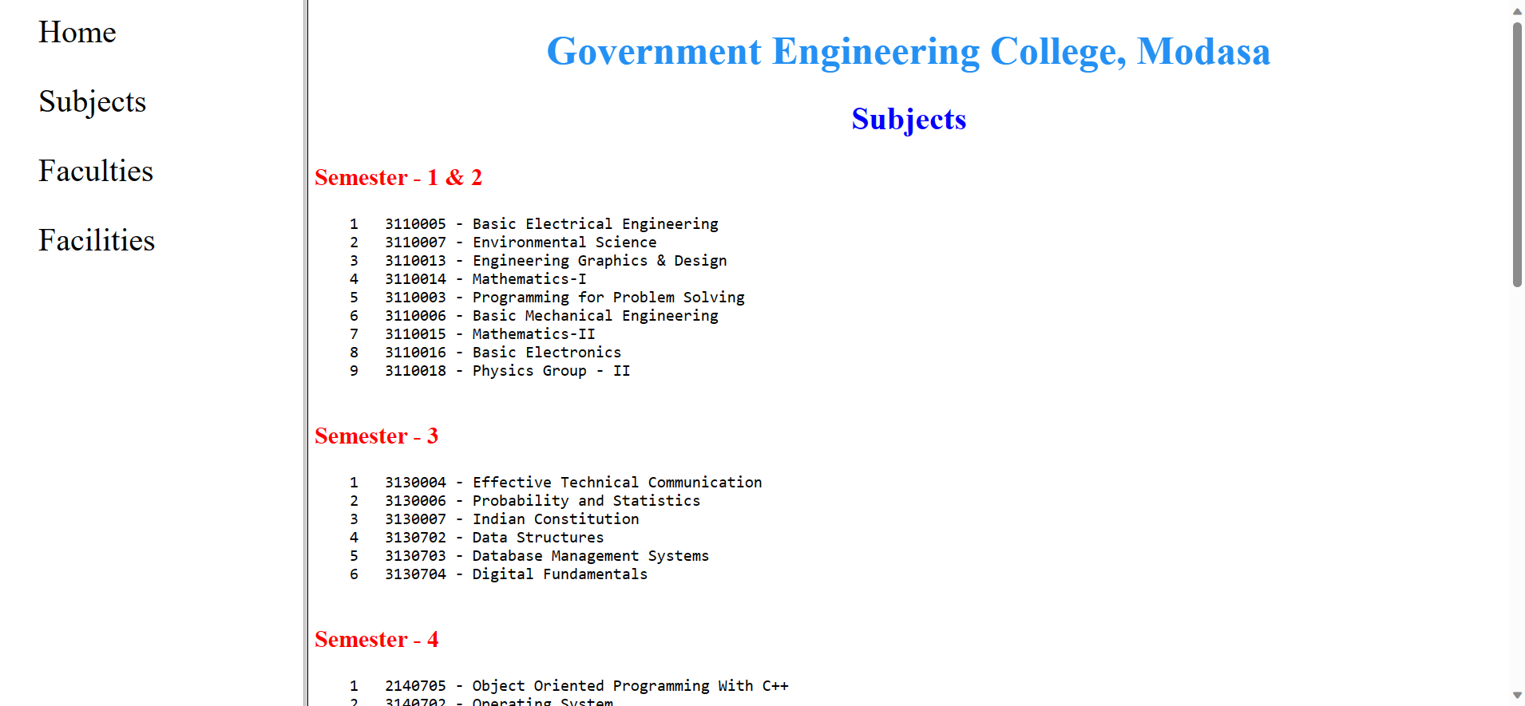

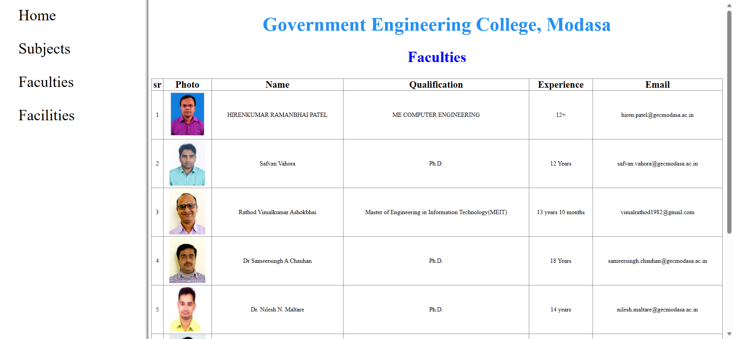

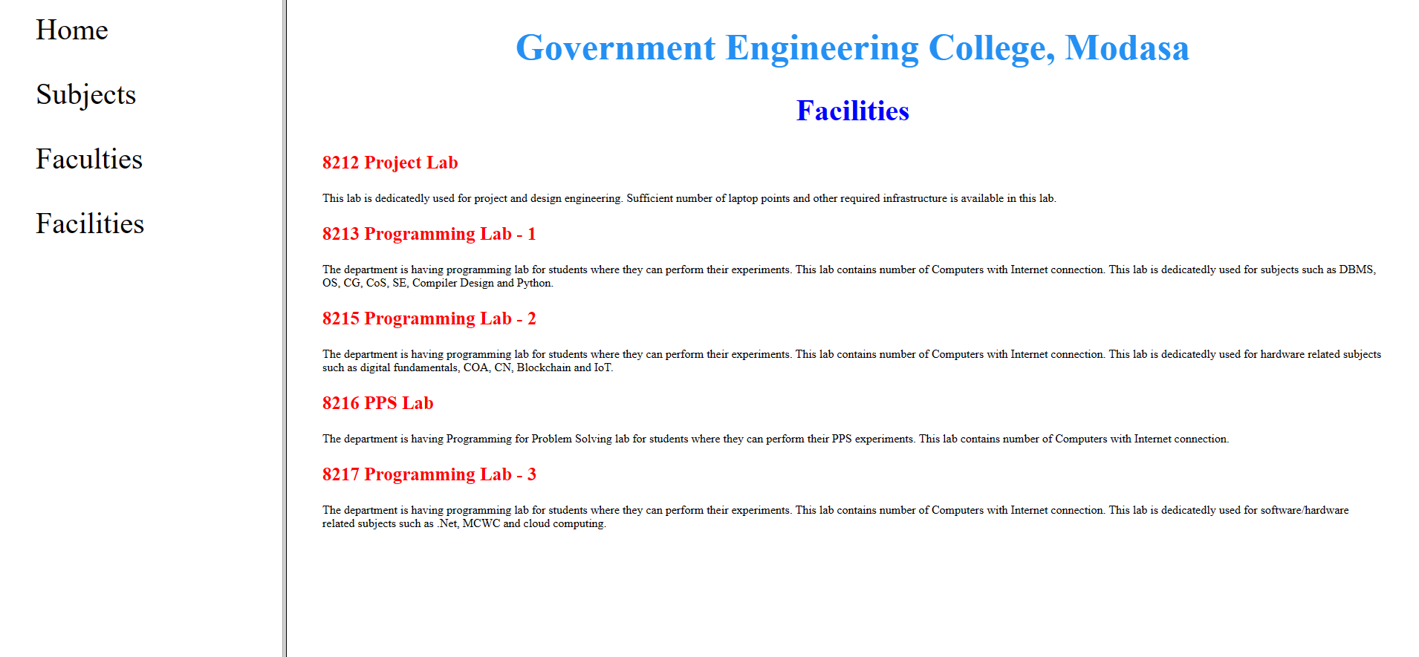

## **Quiz:**

1. **Explain about rows and cols attribute of frame tag.**

The <frame> tag was used in older versions of HTML to define frames within a frameset, which allowed you to divide a web page into multiple sections, each capable of displaying a separate web page. The rows and cols attributes were used to specify the size and arrangement of these frames.

**rows Attribute:** This attribute was used to define the height of rows in a frameset. You could specify the height of each row as a comma-separated list of values or percentages.

For example:

<frameset rows="20%, 60%, 20%">

<!-- Frames go here -->

</frameset>

**cols Attribute:** This attribute was used to define the width of columns in a frameset. You could specify the width of each column as a comma-separated list of values or percentages.

For example:

<frameset cols="25%, 50%, 25%">

<!-- Frames go here -->

</frameset>

1. **Which tag embed an inline frame in a web page?**

To embed an inline frame within a web page, you use the <iframe> (inline frame) tag. The <iframe> element allows you to display another web page or content from a different source within your current web page. Here's a basic example:

<iframe src="https://www.example.com"></iframe>

1. **Which attribute in frame tag is used to specifies the web page to load into that frame?**

In the outdated <frame> tag, the src attribute was used to specify the web page to load into that frame. Here's an example:

<frame src="page1.html">

# **Experiment No: 8**

**Aim:** Design a web page of your home town with an attractive background color, text color, an Image, font etc. (use internal CSS).

## **index.html**

<!DOCTYPE html>

<html lang="en">

<head>

    <title>Home</title>

    <link rel="shortcut icon" type="image/x-icon" href="assets/logo.ico" />

    <link rel="stylesheet" href="css/navbar.css">

    <link rel="stylesheet" href="css/index.css">

</head>

<body>

    <div class="fixed">

        <nav>

            <div class="logoname">

                <img src="assets/logo.jpg " alt="" class="logo">

                <h1>District Junagadh</h1>

            </div>

            <div class="links">

                <a href="index.html" id="selected">Home</a>

                <a href="photos.html">Photos</a>

                <a href="history.html">History</a>

                <a href="map.html">Map</a>

                <a href="tourism.html">Tourism</a>

            </div>

        </nav>

    </div>

    <div id="Home" class="content">

        <div class="about">

            <h1>ABOUT DISTRICT</h1>

            <p>

                Junagadh district is located in western Gujarat and is surrounded by

Arabian sea and forest area. It is located at a longitude of 20.47 N

to 21.45 N and a latitude <br>of 70.15 E to 70.55.

            </p>

            <p>

                The district is divided into 10 talukas of which major ones include,

Junagadh, Keshod, Mangrol, Manavadar. Junagadh is famous for the Gir

Sanctuary, the only abode to Asiatic lions and mountain range of Girnar

which is a major pilgrimage destination.

            </p>

            <p>

                The District Comprises within 05 Revenue Sub-Division & 10 Talukas.

            </p>

        </div>

        <div class="cards">

            <div class="subcard">

                <div class="update">

                    <table>

                        <tr>

                            <th>Election 2022</th>

                            <td><a href="" target="_blank">Download</a></td>

                        </tr>

                        <tr>

                            <th>Covid-19 Updates</th>

                            <td><a href="" target="_blank">Download Guideline</a></td>

                        </tr>

                    </table>

                </div>

                <div class="collector">

                    <img src="assets/collector.jpg" alt="">

                    <div class="about">

                        <b>Collector & District Magistrate</b> <br>

                        Anil Ranavasiya,IAS <br>

                        Phone:+91 2852 636100

                    </div>

                </div>

            </div>

            <div class="subcard2">

                <div class="glance">

                    <table border="1">

                        <tr class="table_head">

                            <th colspan="2">DISTRICT AT GLANCE</th>

                        </tr>

                        <tr>

                            <th>Area</th>

                            <td>5093.36 sq km</td>

                        </tr>

                        <tr><th>Population</th>

                            <td>15,27,329</td></tr>

                        <tr>

                            <th>Literacy Rate</th>

                            <td>78.55%</td>

                        </tr>

                        <tr><th>Block</th>

                            <td>10</td></tr>

                        <tr>

                            <th>Villages</th>

                            <td>547</td>

                        </tr>

                    </table>

                </div>

                <div class="map">

                    <img src="assets/junagdhloc.png" alt="">

                </div>

            </div>

            </div>

    </div>

</body>

</html>

## **photos.html**

<!DOCTYPE html>

<html lang="en">

<head>

    <meta charset="UTF-8">

    <meta name="viewport" content="width=device-width, initial-scale=1.0">

    <title>Photos</title>

    <link rel="shortcut icon" type="image/x-icon" href="assets/logo.ico" />

    <link rel="stylesheet" href="css/navbar.css">

</head>

<body>

    <div class="fixed">

        <nav>

            <div class="logoname">

                <img src="assets/logo.jpg " alt="" class="logo">

                <h1>District Junagadh</h1>

            </div>

            <div class="links">

                <a href="index.html">Home</a>

                <a href="photos.html"id="selected">Photos</a>

                <a href="history.html">History</a>

                <a href="map.html">Map</a>

                <a href="tourism.html">Tourism</a>

            </div>

        </nav>

    </div>

    <div id="Photos" class="content">

        <div class="images">

            <img src="assets/Lion.jpg" alt="">

            <img src="assets/ropway.jpg" alt="">

            <img src="assets/images/1.jpg" alt="">

            <img src="assets/images/2.jpg" alt="">

            <img src="assets/images/3.jpg" alt="">

            <img src="assets/images/4.jpg" alt="">

            <img src="assets/images/5.jpg" alt="">

        </div>

    </div>

</body>

</html>

**history.html**

<!DOCTYPE html>

<html lang="en">

<head>

    <meta charset="UTF-8">

    <meta name="viewport" content="width=device-width, initial-scale=1.0">

    <title>History</title>

    <link rel="shortcut icon" type="image/x-icon" href="assets/logo.ico" />

    <link rel="stylesheet" href="css/navbar.css">

    <link rel="stylesheet" href="css/history.css">

</head>

<body>

    <div class="fixed">

        <nav>

            <div class="logoname">

                <img src="assets/logo.jpg " alt="" class="logo">

                <h1>District Junagadh</h1>

            </div>

            <div class="links">

                <a href="index.html">Home</a>

                <a href="photos.html">Photos</a>

                <a href="history.html" id="selected">History</a>

                <a href="map.html">Map</a>

                <a href="tourism.html">Tourism</a>

            </div>

        </nav>

    </div>

    <div id="History" class="content">

        <img src="assets/images/history.jpg" alt="">

        <h2>History</h2>

        <p>

            History says that ancient names of Junagadh were Karankubj, Manipur,

Revant, Chandraketupur, Narendrapur, Girinagar and also known as

Puratanpur. After 1820 AD British Govt. gave the name Junagadh which is

Registered by the State and is popular in the public. However rural people

even today say refer it as Junagadh. Junagadh was ruled by various rules.

        </p>

        <p>

            In A.D. 640, Chinese traveler Huen Sang visited Junagadh.

        </p>

        <p>

            After 1472 Mohmad Begda, Khalil Khan, Muzaffar, Sikandar, Bahadursha and

Ibadatkhan were ruling Junagadh between 1573 to 1748 Mughals ruled over.

Thereafter various Babis/Nawabs were ruling Junagadh upto 1947. Last Nawab

Of Junagadh Mohabatkhanji left for Karanchi on 9.11.1947 due to attack by

Aarzi Hakumat established by public of Junagadh. In 1949 Junagadh State was

merged with Saurashtra State.

        </p>

    </div>

</body>

</html>

## **map.html**

<!DOCTYPE html>

<html lang="en">

<head>

    <meta charset="UTF-8">

    <meta name="viewport" content="width=device-width, initial-scale=1.0">

    <title>Maps</title>

    <link rel="shortcut icon" type="image/x-icon" href="assets/logo.ico" />

    <link rel="stylesheet" href="css/navbar.css">

    <link rel="stylesheet" href="css/map.css">

</head>

<body>

    <div class="fixed">

        <nav>

            <div class="logoname">

                <img src="assets/logo.jpg " alt="" class="logo">

                <h1>District Junagadh</h1>

            </div>

            <div class="links">

                <a href="index.html">Home</a>

                <a href="photos.html">Photos</a>

                <a href="history.html">History</a>

                <a href="map.html" id="selected">Map</a>

                <a href="tourism.html">Tourism</a>

            </div>

        </nav>

    </div>

    <div id="Map" class="content">

        <input type="radio" id="option1" name="imageSelector" checked>

        <label for="option1">Junagadh</label>

        <input type="radio" id="option2" name="imageSelector">

        <label for="option2">Gujarat</label>

        <input type="radio" id="option3" name="imageSelector">

        <label for="option3">India</label>

        <input type="radio" id="option4" name="imageSelector">

        <label for="option4">All</label>

        <div class="maps">

            <img id="displayImage1" src="assets/maps/junagadh.jpeg">

            <img id="displayImage2" src="assets/maps/Gujarat.png">

            <img id="displayImage3" src="assets/maps/india.png">

        </div>

    </div>

</body>

</html>

## **tourism.html**

<!DOCTYPE html>

<html lang="en">

<head>

    <meta charset="UTF-8">

    <meta name="viewport" content="width=device-width, initial-scale=1.0">

    <title>Tourism</title>

    <link rel="shortcut icon" type="image/x-icon" href="assets/logo.ico" />

    <link rel="stylesheet" href="css/navbar.css">

    <link rel="stylesheet" href="css/tourism.css">

</head>

<body>

    <div class="fixed">

        <nav>

            <div class="logoname">

                <img src="assets/logo.jpg " alt="" class="logo">

                <h1>District Junagadh</h1>

            </div>

            <div class="links">

                <a href="index.html">Home</a>

                <a href="photos.html">Photos</a>

                <a href="history.html">History</a>

                <a href="map.html">Map</a>

                <a href="tourism.html" id="selected">Tourism</a>

            </div>

        </nav>

    </div>

    <div id="tourism" class="content">

        <div class="card">

            <h2>Girnar Hill</h2>

            <div class="contain">

                <img src="assets/tourist/girnar.jpg" alt="">

                <p>

Girnar, also known as Girinagar or Revatak Parvata, is a group of mountains in the Junagadh District of Gujarat, India, situated near Junagadh. Is considered older than the Himalayas, Girnar, the mountain and its range are considered sacred. It is an important pilgrimage site for both Hindus , who gather here during the Girnar Parikrama festival. Later on some Jain temples were also built, some of which are very recent. Girnar is one of the five major ‘tirthas’ attributed to the ‘panch kalyanakas’ of various ‘Jain tirthankaras’. Girnar is also significant among Shiva devotees for the so-called “mystic space-time” of the mountain range, with the presence and turnover of different sects of Sadhu Babas, Nath sect and others. Flora and fauna fairs are also held at the mountains, such as the Maha Shivratri fair. Different Jain Tirthankaras and monks have in the past visited and practiced severe penance at the peaks of Girnar. It hosts a number of temples and some historical spots across its range. Amidst the lush green Gir Forest, the mountain range serves as the hub of religious activity.

</p>

            </div>

        </div>

        <div class="card">

            <h2>Mahabat Maqbara</h2>

            <div class="contain">

                <p>

Mahabat Maqbara Palace, also Mausoleum of Bahaduddinbhai Hasainbhai, is a mausoleum in Junagadh, India, that was once home to the Muslims rulers the Nawabs of Junagadh. The city of Junagadh has other 18th-century mausoleums built by the nawabs in the area around Chitkana Chowk.

</p>

                <img src="assets/tourist/mahabat.jpg" alt="">

            </div>

        </div>

        <div class="card">

            <h2>Damodar Kund</h2>

            <div class="contain">

                <img src="assets/tourist/damodar.jpg" alt="">

                <p>

Damodar Kund is one of the sacred lakes as per Hindu beliefs, which is located at the foothills of Girnar hills, near Junagadh in Gujarat, India. It is considered holy, as per Hindu mythology and many Hindus prefer to bathe and immerse the ashes and the bones left after cremation of dead bodies, here at Damodar Kund due to a belief that the departed souls would get moksha here.It may be mentioned here other such famous places for immersion of ashes and bones ( Hindu rite of asthi-visarjana ) are in Ganga at Haridwar and Triveni Sangam at Prayag. The water of the lake has properties of dissolving the bones.The lake is 257 ft long and 50 ft broad and only 5 feet deep. It is surrounded by a well built ghat.The steps for going up the Girnar hills start near Damodar Kund.

</p>

            </div>

        </div>

        <div class="card">

            <h2>Willingdon Dam</h2>

            <div class="contain">

                <p>

The dam is built on the river Kalwa at the foot of the hill from where it originates. It was built as a reservoir for drinking water for the people of Junagadh. It was named after Lord Willingdon, the then Governor of India. Near the dam, the steps go up to 2,779 feet (847 m) high to the famous shrine of Jamiyal shah Datar, where both Hindu and Muslim devotees share their faith.

</p>

                <img src="assets/tourist/willingdon.jpg" alt="">

            </div>

        </div>

        <div class="card">

            <h2>Sasan Gir Forest</h2>

            <div class="contain">

                <img src="assets/tourist/sasan.jpg" alt="">

                <p>

Gir is one of India’s oldest sanctuaries, and is synonymous with the majestic Asiatic lion (Panthera leo persica). The only place in India to see this animal, this park can take legitimate pride in saving an endangered species, which was at the threshold of extinction in the start of the twenty-first century, by providing it a more secured habitat. The Gir ecosystem falls in Biogeography Zone-4 (the semi arid) and Biogeography Province 4-B. Gujarat Rajwara is the last remaining abode of the Asiatic Lion, Panthera leo persica. The Government of Gujarat has declared an area of 1412.1 sq km as Protected Area (PA) which comprises 258.7 sq km as National Park and 1153.4 sq km as Sanctuary. Besides this 470.5 sq km of forest area forms a buffer Zone as reserve, protected and unclassified forest. Thus, a total area of 1882.6 sq km makes up the Gir forest. For Booking Gir Jungle Trail & Devaliya Safari :

<a href="http://girlion.in/" target="_blank">[http://girlion.in/</a](http://girlion.in/%3c/a)>

</p>

            </div>

        </div>

        <div class="card">

            <h2>Sakkarbaugh Zoo</h2>

            <div class="contain">

                <p>

Sakkarbaug Zoological Garden also known as Sakkarbaug Zoo or Junagadh Zoo is a 200-hectare (490-acre) zoo that opened in 1863 at Junagadh, Gujarat, India. The zoo provides purebred Asiatic lions for the Indian and the international endangered species captive breeding program for the critically endangered species. Wild free ranging Asiatic lions have become extinct over most of Asia and are today found only in the nearby Gir Forest.

<br><br>

<b>Sakkarbaugh Zoo Timings :</b>

<br><br>

All days of the week except Wednesday

<br><br>

9:00 AM – 6:30 PM

</p>

                <img src="assets/tourist/sakkarbag.jpg" alt="">

            </div>

        </div>

    </div>

</body>

</html>

## **navbar.css**

@import url('https://fonts.googleapis.com/css2?family=Dancing+Script:wght@700&family=Lora:ital@1&family=Roboto&display=swap');

*{

    padding: 0;

    margin: 0;

    font-family: 'Roboto', sans-serif;

}

.logo{

    height: 80px;

    width: 80px;

    border-radius: 50%;

    border: 2px solid black;

}

.logoname h1{

    font-size: 50px;

    padding-left: 40px;

    font-family: 'Dancing Script', cursive;

}

.logoname{

    display: flex;

    justify-content: left;

    align-items: center;

    padding: 10px;

    padding-left: 20px;

    width: 65%;

}

nav{

    display: flex;

    justify-content: left;

    align-items: center;

    width: 100%;

    border-bottom: 2px solid black;

    background-color: rgb(255, 255, 255);

}

.fixed{

    position: fixed;

    width: 100%;

    top: 0;

}

.links{

    display: flex;

    justify-content: left;

    align-items: center;

    width: 50%;

}

.links a{

    text-decoration: none;

    color: black;

    font-size: 20px;

    border: 1px solid black;

    padding: 10px 20px;

    margin: 10px;

    border-radius: 8px;

    font-family: 'Lora', serif;

    font-weight: bold;

}

.links a:hover{

    background-color:  #00B043;

    color: white;

    border: 1px solid black;

}

.links #selected:hover{

    background-color: white;

}

#selected{

    color: #00B043;

}

.content{

    padding-top: 110px;

}

.images{

    display: flex;

    flex-wrap: wrap;

    justify-content: space-evenly;

}

.images img{

    height: 240px;

    padding: 10px;

}

## **index.css**

.collector{

    border: 1px solid black;

    height: 115px;

    width: 400px;

    padding: 10px;

    display: flex;

    align-items: center;

}

.collector img{

    height: 112px;

    width: 88px;

    padding-right: 20px;

}

.update{

    margin-top: 10px;

    width: 400px;

    height: 115px;

}

.about h1{

    padding: 15px 40px;

}

.about p{

    font-size: 20px;

    padding: 10px 40px;

}

.cards{

    display: flex;

    align-items: start;

    margin-left: 10px;

    margin-top: 20px;

    justify-content: space-evenly;

}

.glance{

    width: 400px;

    height: 280px;

}

table{

    text-align: left;

    font-size: 20px;

    width: 100%;

    height: 100%;

    border-collapse: collapse;

}

th, td{

    padding: 10px;

    padding: 10px;

}

tr:nth-child(2n){

    background-color: rgb(222, 222, 222);

}

.table_head{

    text-align: center;

    font-size: 25px;

}

.update table tr{

    background-color: white;

}

.update table tr a{

    text-decoration: none;

}

.subcard2{

    display: flex;

}

## **map.css**

input[type="radio"] {

    display: none;

}

label {

    display: inline-block;

    padding: 10px 20px;

    margin: 10px;

    background-color: #ccc;

    background-color: white;

    cursor: pointer;

    border: 1px solid black;

}

input[type="radio"]:checked + label {

    background-color: #ccc;

    color: black;

    border: 1px solid black;

    font-weight: bold;

}

#displayImage1, #displayImage2, #displayImage3 {

    max-width: 100%;

    height: 60vh;

    margin-top: 20px;

    display: none;

}

#option1:checked ~ .maps #displayImage1 {

    display: block;

}

#option2:checked ~ .maps #displayImage2 {

    display: block;

}

#option3:checked ~ .maps #displayImage3 {

    display: block;

}

#option4:checked ~ .maps #displayImage1 {

    display: block;

}

#option4:checked ~ .maps #displayImage2 {

    display: block;

}

#option4:checked ~ .maps #displayImage3 {

    display: block;

}

#option4:checked ~ .maps{

    display: flex;

    justify-content: space-evenly;

}

.content{

    padding-left: 50px;

}

## **history.css**

h2{

    padding: 15px;

    font-size: 30px;

}

p{

    font-size: 20px;

    padding: 10px;

}

#History img{

    width: 100%;

}

## **tourism.css**

.contain{

    display: flex;

    padding-top: 10px;

    font-size: 20px;

}

.card {

    padding: 20px 80px;

}

.card h2{

    font-size: 25px;

}

.contain img:nth-child(2n-1){

    padding-right: 50px;

}

.contain img:nth-child(2n){

    padding-left: 50px;

}

## **Output**

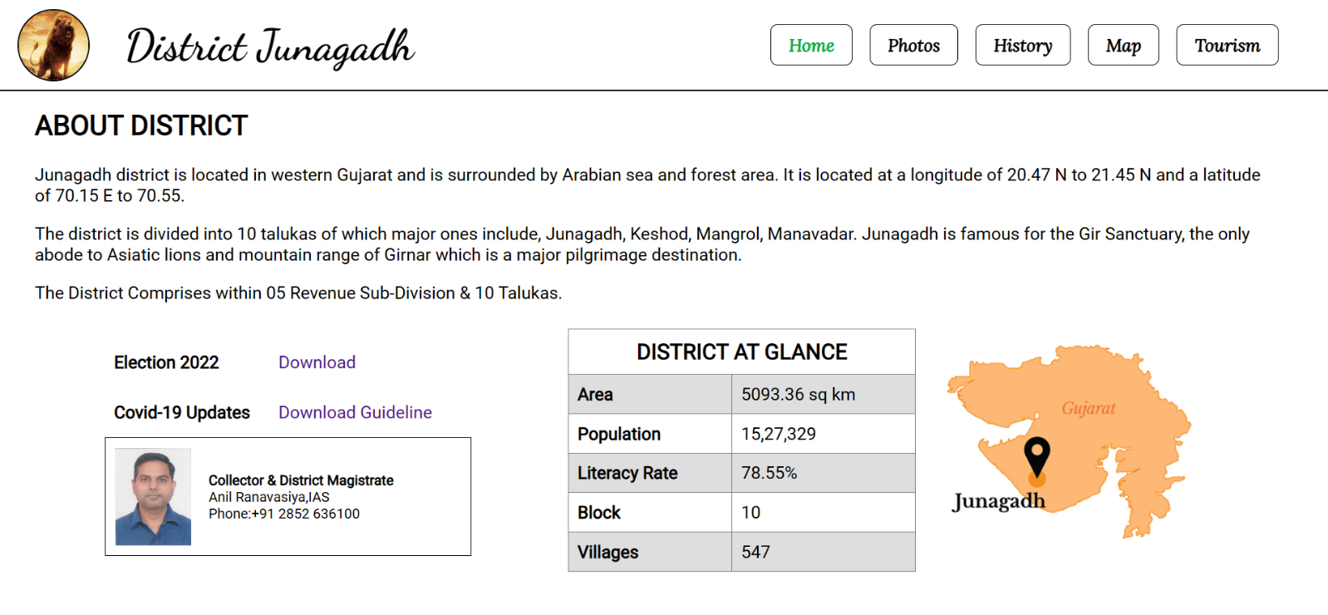

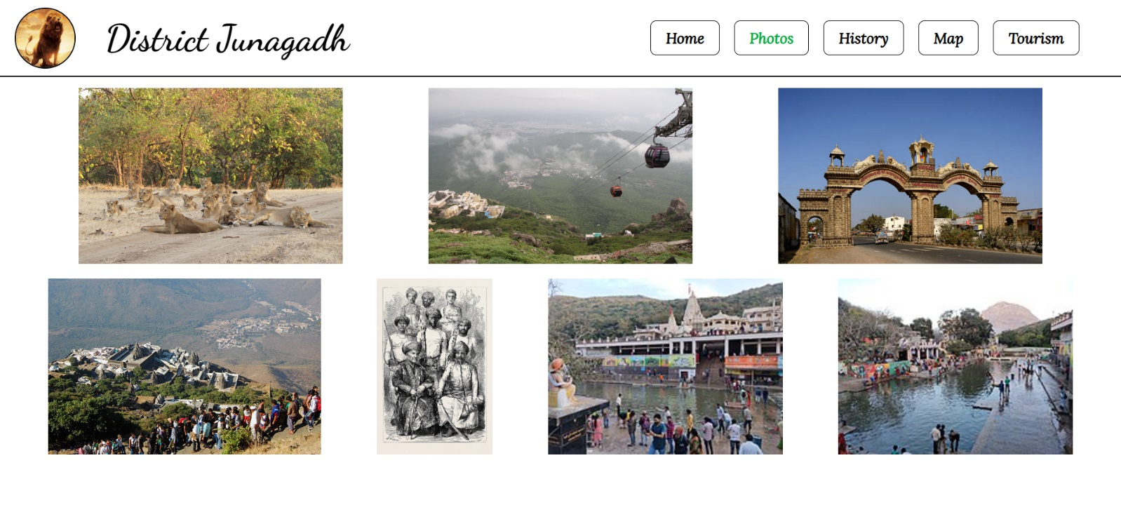

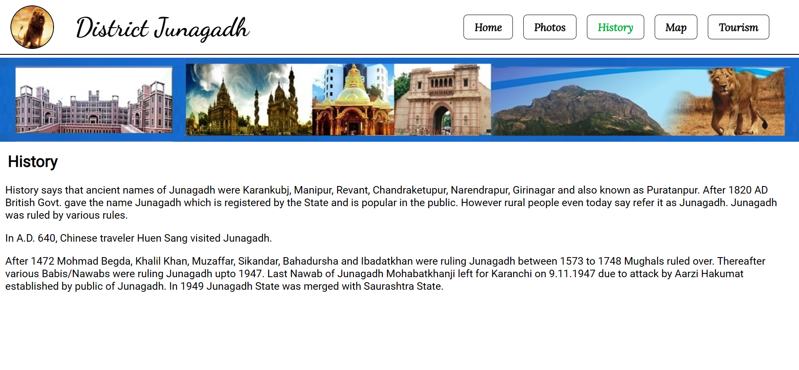

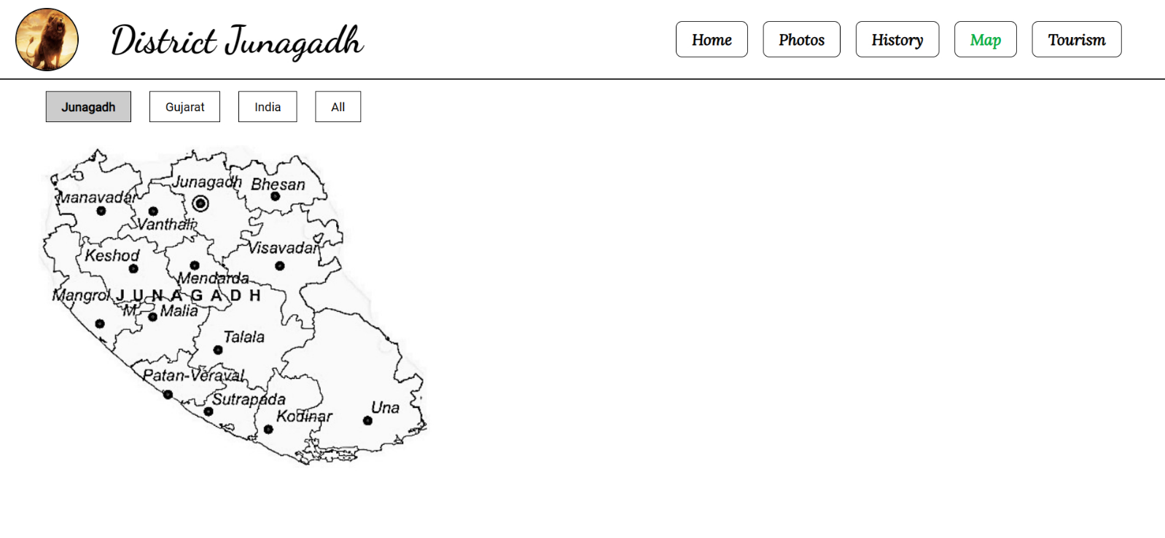

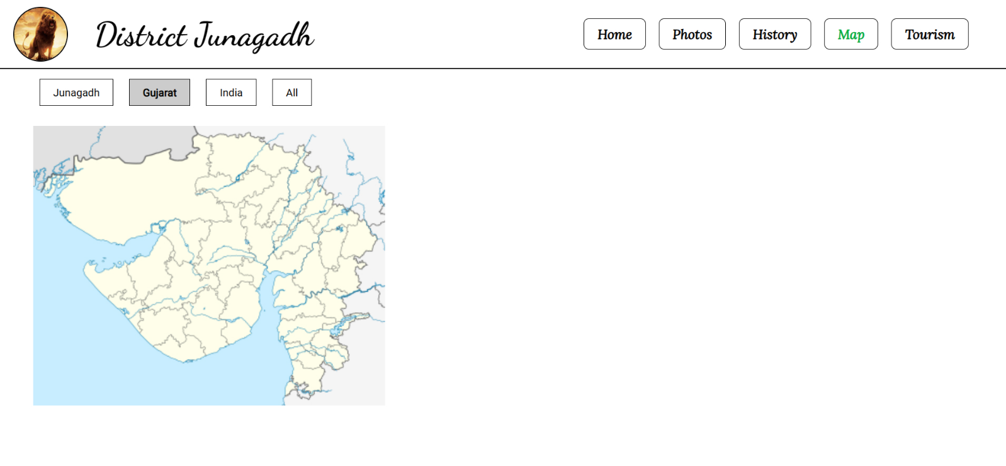

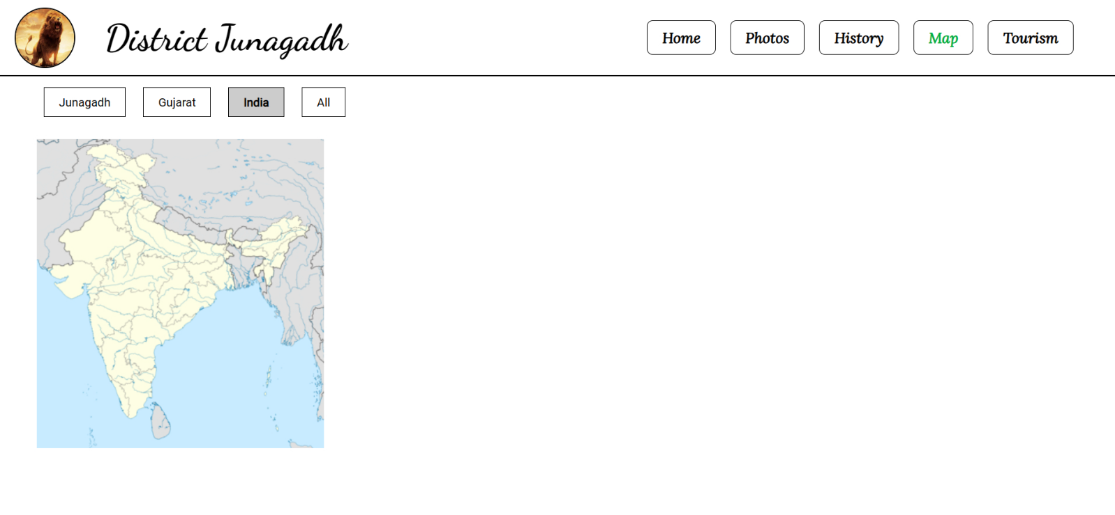

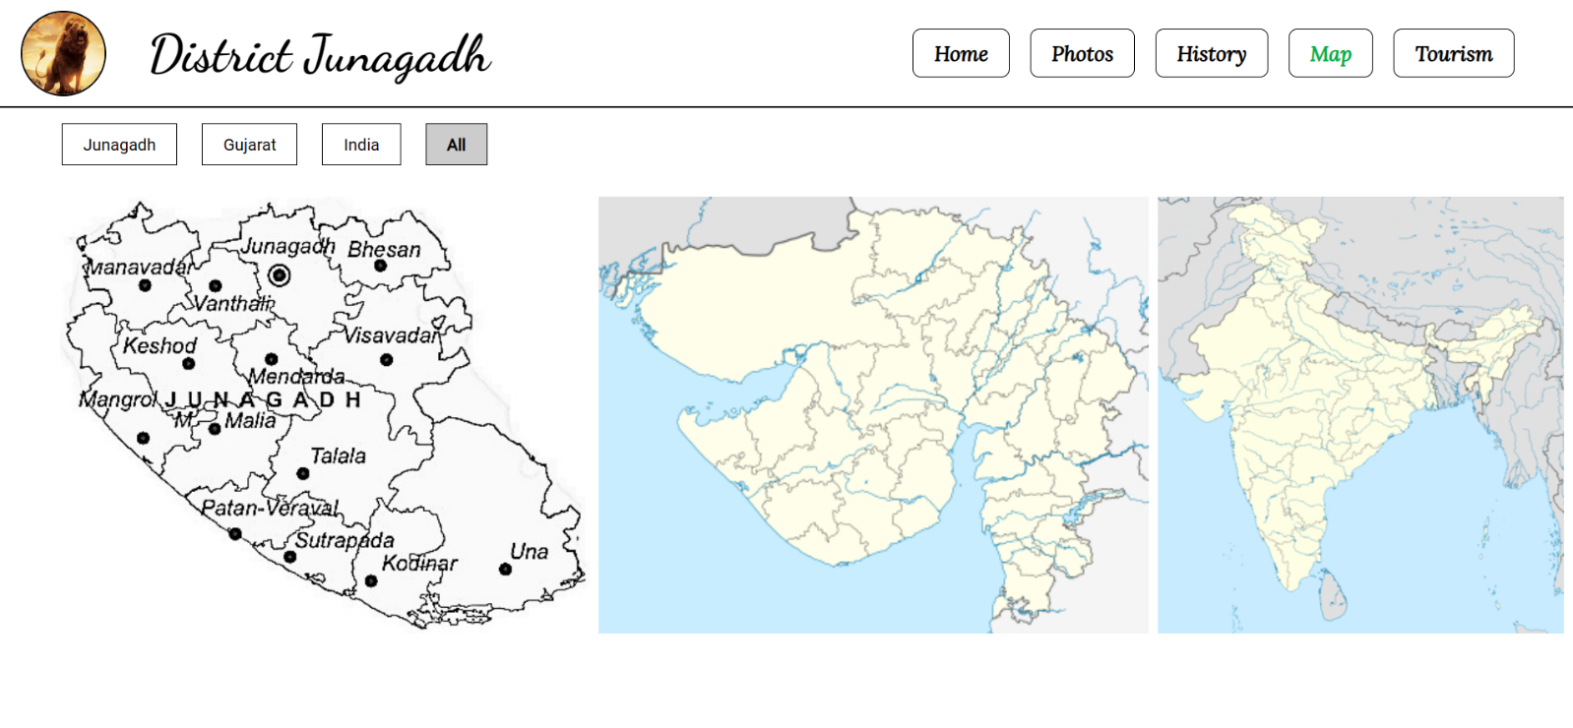

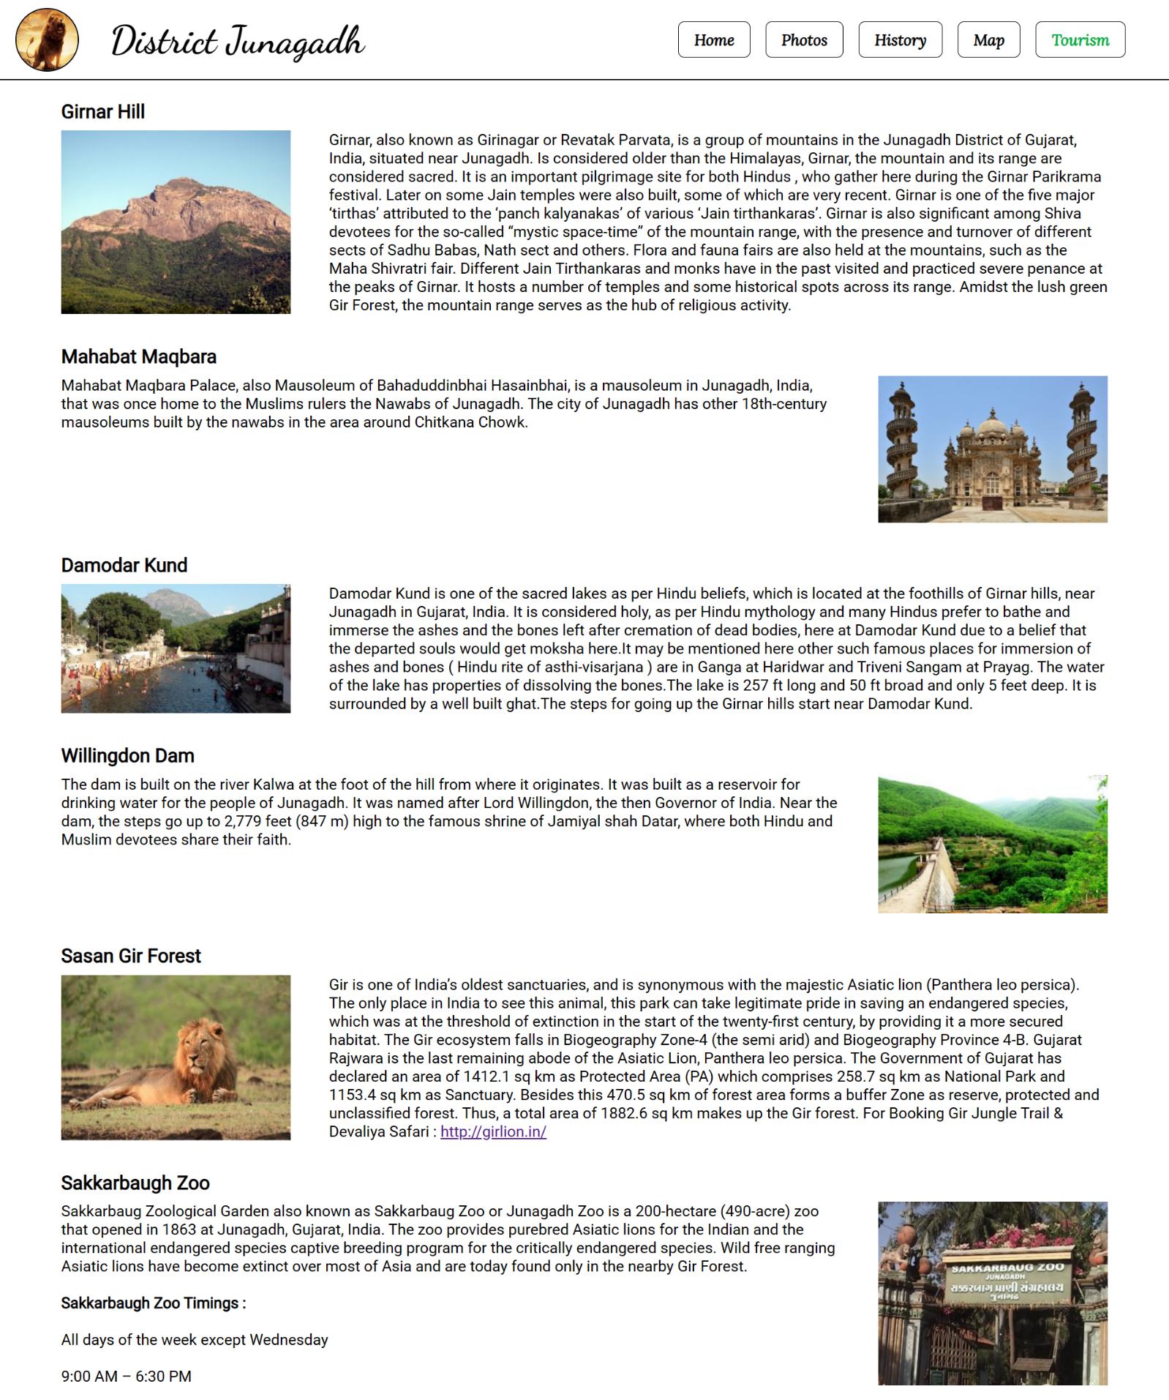

## **Quiz:**

1. **Explain the syntax of the CSS.**

CSS (Cascading Style Sheets) is a stylesheet language used for describing the presentation and styling of HTML or XML documents. CSS uses a specific syntax to define styles and apply them to HTML elements. Here's a brief overview of the syntax:

**Selectors**: Selectors are used to target HTML elements to which you want to apply styles. They can be HTML element names (e.g., p for paragraphs), class names (e.g., .my-class), or IDs (e.g., #my-id).

**Declaration Block:** A declaration block consists of one or more declarations enclosed in curly braces {}. Each declaration defines a property and a value, separated by a colon :. For example: color: blue;.

**Property:** The property is a specific styling attribute you want to apply, such as color, font-size, or margin. It comes before the colon in a declaration.

**Value:** The value is the setting you want for the property, such as blue, 16px, or 10px 20px. It comes after the colon in a declaration.

**Declaration:** A declaration consists of a property and its associated value. Multiple declarations within a declaration block are separated by semicolons ;.

**Rule Set:** A rule set is a combination of a selector and a declaration block. It specifies which elements the styles in the declaration block should apply to.

For example:

/* Selector */

h1 {

/* Declaration Block */

color: red; /* Property and Value */

font-size: 24px;

}

1. **What is internal CSS ?**

Internal CSS, also known as embedded CSS, involves placing CSS code directly within an HTML document using the <style> element. It's typically placed within the <head> section of the HTML document.

For example:

<head>

    <title>Internal CSS Example</title>

    <style>

        /* Internal CSS */

        h1 {

            color: blue;

        }

    </style>

</head>

1. **Explain CSS class and Id selector.**

**Class Selector (.class-name):**

Class selectors are used to target HTML elements that have a specific class attribute. You can apply the same class to multiple elements, allowing you to style them consistently. To select elements with a specific class, you prefix the class name with a period (.).

For example:

/* Define a class selector */

.highlight {

    background-color: yellow;

    color: black;

}

**ID Selector (#id-name):**

ID selectors are used to target a unique HTML element with a specific ID attribute. Each ID should be unique within a document. To select an element with a specific ID, you prefix the ID name with a hash (#).

For example:

/* Define an ID selector */

#header {

font-size: 24px;

text-align: center;

}

# **Experiment No: 9**

**Aim:** Use Inline CSS to format your resume that you created in practical no 02.

## **index.html**

<!DOCTYPE html>

<html lang="en">

<head>

    <meta charset="UTF-8">

    <meta name="viewport" content="width=device-width, initial-scale=1.0">

    <title>Resume</title>

    <link rel="stylesheet" href="css/sytle.css">

</head>

<body>

    <div class="main">

        <div class="head">

            <h1>Resume</h1>

        </div>

        <div class="photo">

            <img src="assets/photo.png" alt="">

        </div>

        <div class="personal_details">

            <div class="top">

                <img src="assets/icon/personal detals.png" alt="">

                <h2>Personal Details</h2>

            </div>

            <table>

                <tr>

                    <th>Name</th>

                    <td>Malam Hari</td>

                </tr>

                <tr>

                    <th>Mobile</th>

                    <td>7284080686</td>

                </tr>

                <tr>

                    <th>Email</th>

                    <td>malamharid@gmail.com</td>

                </tr>

                <tr>

                    <th>Age</th>

                    <td>20</td>

                </tr>

                <tr>

                    <th>Gender</th>

                    <td>Male</td>

                </tr>

                <tr>

                    <th>Birth Date</th>

                    <td>01/09/2003</td>

                </tr>

                <tr>

                    <th>Address</th>

                    <td>Junagadh</td>

                </tr>

            </table>

        </div>

        <div class="education_details">

            <div class="top">

                <img src="assets/icon/educational details.png" alt="">

                <h2>Education Details</h2>

            </div>

            <table border="1">

                <tr>

                    <th>Standard</th>

                    <th>Board</th>

                    <th>Year</th>

                    <th>Percentage</th>

                </tr>

                <tr>

                    <td>10<sup>th</sup></td>

                    <td>GSHEB</td>

                    <td>2019</td>

                    <td>77.5</td>

                </tr>

                <tr>

                    <td>12<sup>th</sup></td>

                    <td>GSHEB</td>

                    <td>2021</td>

                    <td>82.5</td>

                </tr>

                <tr>

                    <td>IT (BE)</td>

                    <td>GTU</td>

                    <td>2025</td>

                    <td>9.2</td>

                </tr>

            </table>

        </div>

        <div class="skills">

            <div class="top">

                <img src="assets/icon/skills.jpeg" alt="">

                <h2>Skills</h2>

            </div>

            <div class="skill">

                <table>

                    <tr>

                        <th><img src="assets/icon/html.png""></th>

                    <td>HTML</td>

                </tr>

                <tr>

                    <th><img src=" assets/icon/css.png" alt=""></th>

                        <td>CSS</td>

                    </tr>

                    <tr>

                        <th><img src="assets/icon/js.png" alt=""></th>

                        <td>Java Script</td>

                    </tr>

                    <tr>

                        <th><img src="assets/icon/php.png" alt=""></th>

                        <td>PHP</td>

                    </tr>

                </table>

                <table>

                    <tr>

                        <th><img src="assets/icon/c.png" alt=""></th>

                        <td>C</td>

                    </tr>

                    <tr>

                        <th><img src="assets/icon/java.png" alt=""></th>

                        <td>Java</td>

                    </tr>

                    <tr>

                        <th><img src="assets/icon/python.png" alt=""></th>

                        <td>Python</td>

                    </tr>

                    <tr>

                        <th><img src="assets/icon/sql.png" alt=""></th>

                        <td>My SQL</td>

                    </tr>

                </table>

                <table>

                    <tr>

                        <th><img src="assets/icon/mongo.jpg" alt=""></th>

                        <td>Mongo DB</td>

                    </tr>

                    <tr>

                        <th><img src="assets/icon/photoshop.png" alt=""></th>

                        <td>Photoshop</td>

                    </tr>

                    <tr>

                        <th><img src="assets/icon/git.jpg" alt=""></th>

                        <td>Git</td>

                    </tr>

                    <tr>

                        <th><img src="assets/icon/office.png" alt=""></th>

                        <td>MS Office</td>

                    </tr>

                </table>

            </div>

        </div>

        <div class="experience">

            <div class="top">

                <img src="assets/icon/experience.png" alt="">

                <h2>Experience</h2>

            </div>

            <table border="1" style="border-collapse: collapse;">

                <tr>

                    <th>Company</th>

                    <th>Profession</th>

                    <th>Duration</th>

                </tr>

                <tr>

                    <td>TCS</td>

                    <td>Java intern</td>

                    <td>6 month</td>

                </tr>

                <tr>

                    <td>Microsoft</td>

                    <td>Junior Java Developer</td>

                    <td>1 year</td>

                </tr>

                <tr>

                    <td>Google</td>

                    <td>Java Developer</td>

                    <td>1 year</td>

                </tr>

            </table>

        </div>

        <div class="declaration">

            <div class="top">

                <img src="assets/icon/declare.png" alt="">

                <h2>Declaration</h2>

            </div>

            <p>I herreby declare that the details and information given above are compelete and true to the best of my

                knowledge</p>

            <img class="sing" src="assets/Sing.jpg" height="50px" width="160px" alt="">

        </div>

    </div>

</body>

</html>

## **style.css**

*{

    padding: 0;

    margin: 0;

    font-size: 25px;

    font-family: 'Gill Sans', 'Gill Sans MT', Calibri, 'Trebuchet MS', sans-serif;

}

body{

    background-color: #F0EFEF;

}

.main{

    margin: 50px;

    display: flex;

    flex-wrap: wrap;

    justify-content: space-between;

    align-items: start;

}

.head{

    width: 100%;

    text-align: center;

    background-color: white;

    border-radius: 10px;

    padding: 10px;

    margin: 10px;

    border: 4px solid black;

    margin-bottom: 30px;

}

.head h1{

    font-size: 30px;

}

.top img{

    height: 40px;

    width: 40px;

    padding: 2px;

    padding-right: 10px;

    padding-left: 10px;

}

.top{

    display: flex;

    align-items: center;

    padding-bottom: 10px;

}

h2{

    padding: 2px;

    font-size: 30px;

    margin-bottom: 10px;

}

.photo{

    background-color: white;

    border-radius: 10px;

    padding: 10px;

    margin: 10px;

    width: 15%;

    height: 300px;

    display: flex;

    text-align: center;

    justify-content: center;

    width: auto;

}

.photo img{

    width: 100%;

    height: auto;

}

.personal_details{

    border-radius: 10px;

    margin: 10px;

    background-color: white;

    width: 78%;

    width: 38%;

    height: 300px;

    padding: 10px;

    margin-bottom: 30px;

}

.personal_details table{

    width: 700px;

    text-align: left;

    padding-left: 10px;

}

.personal_details td{

    padding: 2px;

}

.education_details{

    background-color: white;

    width: 35%;

    height: 300px;

    border-radius: 10px;

    margin: 10px;

    padding: 10px;

    margin-bottom: 30px;

    width: auto;

}

.declaration img{

    padding: 10px;

}

.education_details table{

    width: 500px;

    height: 80%;

    text-align: center;

    margin-left: 4px;

    border-collapse: collapse;

    border-color: #bcbcbc;

}

.skills{

    width: 100%;

    height: 300px;

    background-color: white;

    border-radius: 10px;

    margin: 10px;

    padding: 10px;

    margin-bottom: 30px;

    width: auto;

}

.skills table{

    padding: 10px;

    width: 250px;

    text-align: left;

}

.skill{

    display: flex;

    justify-content: space-between;

}

.experience{

    background-color: white;

    height: 300px;

    border-radius: 10px;

    margin: 10px;

    padding: 10px;

    width: 40%;

    margin-bottom: 30px;

}

.experience table{

    background-color: white;

    height: 80%;

    border-radius: 10px;

    width: 100%;

    text-align: center;

    border-color: #bcbcbc;

}

.declaration{

    width: 100%;

    border-radius: 10px;

    background-color: white;

    margin-top: 30px;

    padding: 10px;

}

## **Output**

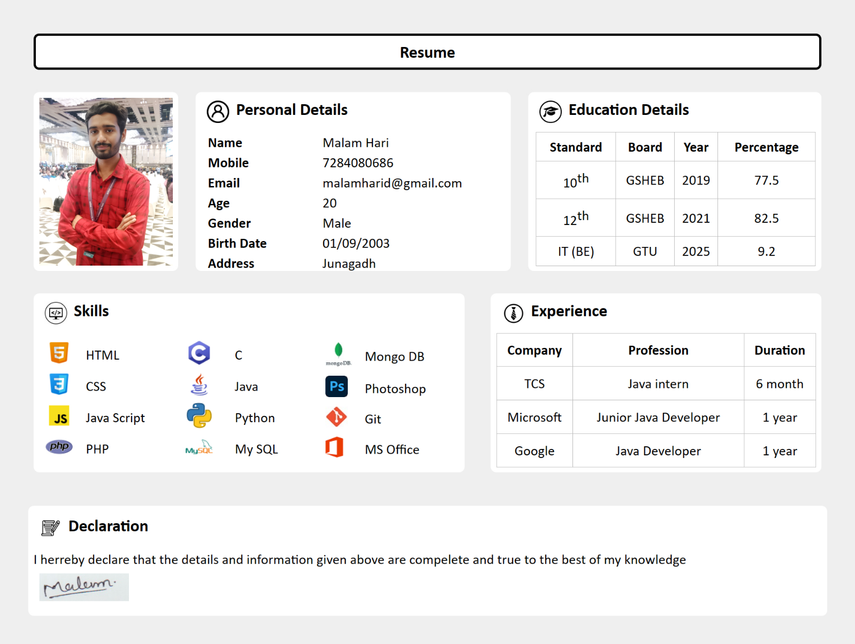

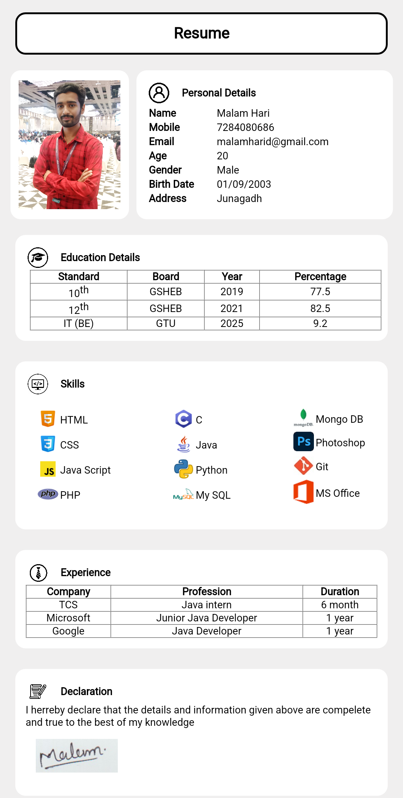

## **Quiz:**

1. **Explain Internal CSS VS Inline CSS.**

**Internal CSS (Embedded CSS):**

**Location:** Internal CSS is placed within the <style> element, typically in the <head> section of an HTML document.

**Scope:** Styles defined internally apply to the entire HTML document in which they are embedded.

**Usage:** Internal CSS is useful when you want to apply styles to a single HTML document. It's suitable for small-scale projects or when you need specific styles for a single page.

Example:

<!DOCTYPE html>

<html>

<head>

    <style>

        body {

            background-color: lightgray;

        }

        h1 {

            color: blue;

        }

    </style>

</head>

<body>

    <h1>Hello, World!</h1>

    <p>This is a paragraph with internal CSS styles.</p>

</body>

</html>

**Inline CSS:**

**Location:** Inline CSS is applied directly to individual HTML elements using the style attribute within the element's tag.

**Scope:** Inline styles apply only to the specific HTML element to which they are applied.

**Usage:** Inline CSS is useful for making quick, one-off style changes to specific elements within an HTML document. However, it can become hard to maintain and manage as the page becomes more complex.

Example:

<p style="color: red; font-size: 18px;">This is a red, larger text paragraph.</p>

1. **CSS stands for .**

CSS stands for Cascading Style Sheets. It is a stylesheet language used to define the presentation and styling of HTML (or XML) documents. CSS enables web developers to control the layout, colors, fonts, spacing, and other visual aspects of web content, allowing for the separation of content (HTML) and presentation (CSS).

1. **Which HTML tag is used to define an internal style sheet?**

The HTML tag used to define an internal (embedded) style sheet is the <style> element. The <style> element is typically placed within the <head> section of an HTML document and contains CSS code that defines styles for that specific document.

Here's an example:

<!DOCTYPE html>

<html>

<head>

    <style>

        body {

            background-color: lightgray;

        }

        h1 {

            color: blue;

        }

    </style>

</head>

<body>

    <h1>Hello, World!</h1>

    <p>This is a paragraph with internal CSS styles.</p>

</body>

</html>

# **Experiment No: 10**

**Aim:** Use External, Internal, Inline CSS to format Information Technology Department Web Pages that you created in Practical No.04

## **index.html**

<!DOCTYPE html>

<html lang="en">

<head>

    <meta charset="UTF-8">

    <meta name="viewport" content="width=device-width, initial-scale=1.0">

    <title>College Website</title>

    <link rel="stylesheet" href="style.css">

</head>

<body>

    <div class="fixed">

        <nav>

            <div class="logoname">

                <img src="logo.png" alt="" class="logo">

                <h1>Government Engineering College, Modasa</h1>

            </div>

            <div class="links">

                <a href="Web/home.html" target="target">HOME</a>

                <a href="Web/subjects.html" target="target">SUBJECTS</a>

                <a href="Web/faculties.html" target="target">FACULTIES</a>

                <a href="Web/facilities.html" target="target">FACILITIES</a>

            </div>

        </nav>

    </div>

    <div style="height: 100vh;">

        <iframe name="target" width="99%" height="100%"></iframe>

    </div>

</body>

</html>

## **style.css**

@import url('https://fonts.googleapis.com/css2?family=Dancing+Script:wght@700&family=Lora:ital@1&family=Roboto&display=swap');

*{

    padding: 0;

    margin: 0;

    font-family: 'Roboto', sans-serif;

}

.logo{

    height: 80px;

    width: 80px;

}

.logoname h1{

    font-size: 30px;

    padding-left: 40px;

    color: rgb(36, 144, 244);

}

.logoname{

    display: flex;

    justify-content: left;

    align-items: center;

    padding: 10px;

    padding-left: 20px;

    width: 65%;

}

nav{

    display: flex;

    justify-content: left;

    align-items: center;

    width: 100%;

    border-bottom: 2px solid black;

    background-color: rgb(255, 255, 255);

}

.fixed{

    position: fixed;

    width: 100%;

    top: 0;

}

.links{

    display: flex;

    justify-content: left;

    align-items: center;

    width: 50%;

}

.links a{

    text-decoration: none;

    color: black;

    font-size: 20px;

    border: 1px solid black;

    padding: 10px 20px;

    margin: 10px;

    border-radius: 8px;

    font-family: 'Lora', serif;

    font-weight: bold;

}

.links a:hover{

    background-color: rgb(36, 144, 244);

    color: white;

    border: 1px solid black;

}

## **Output**

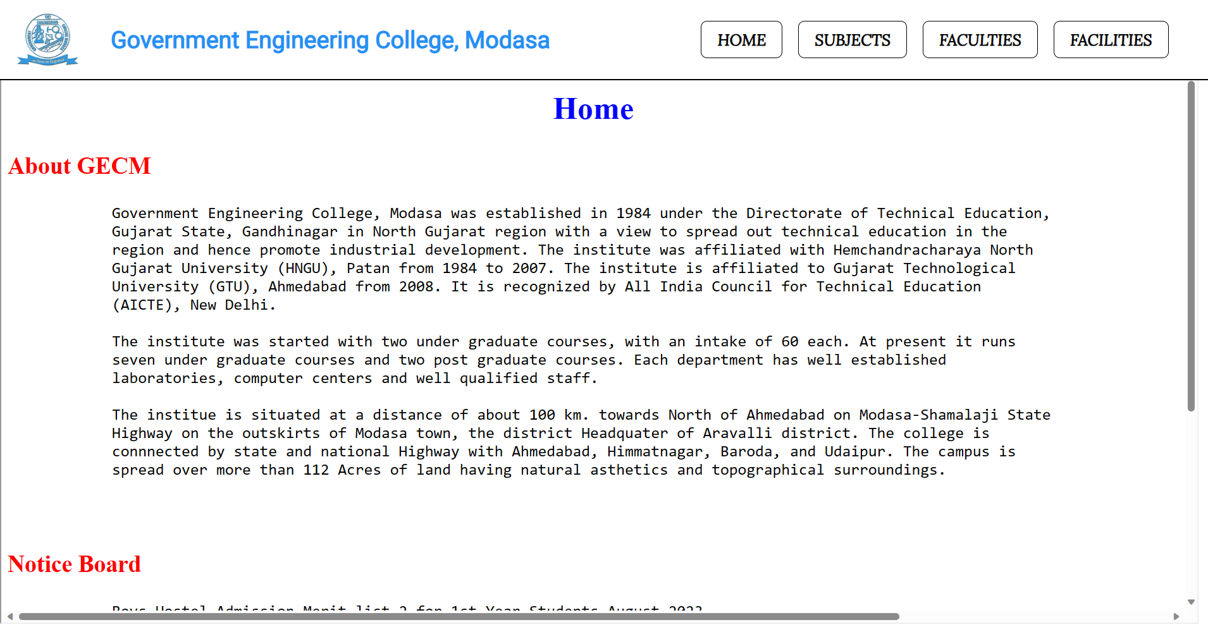

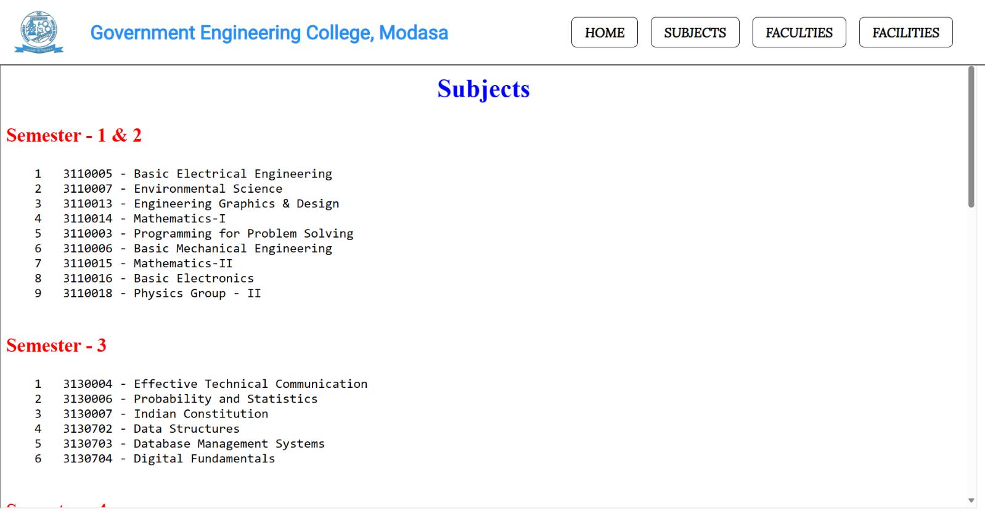

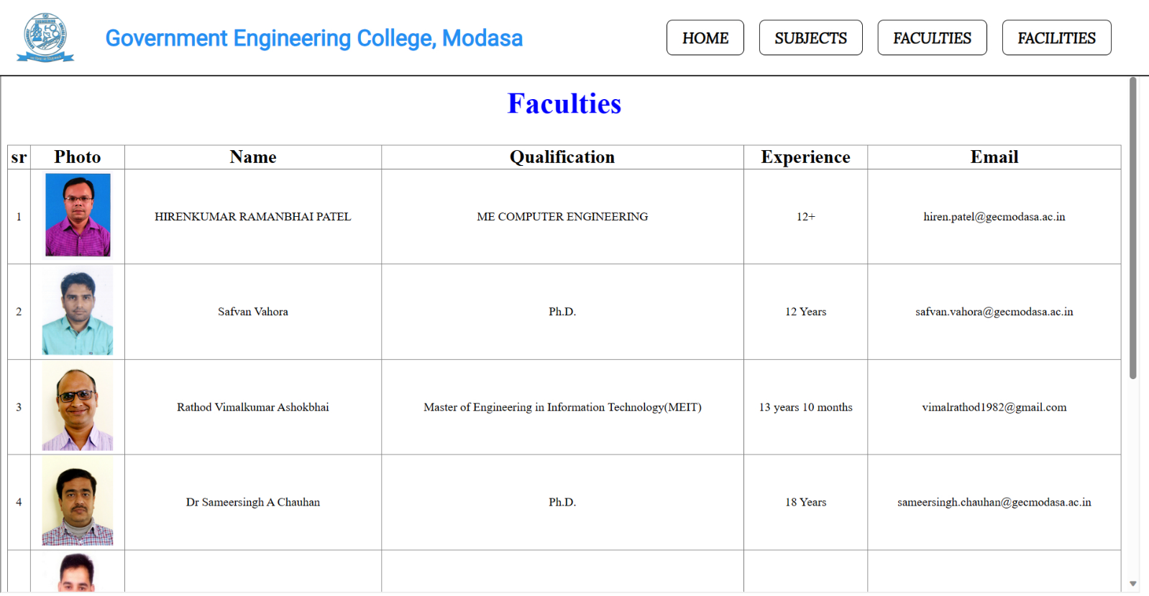

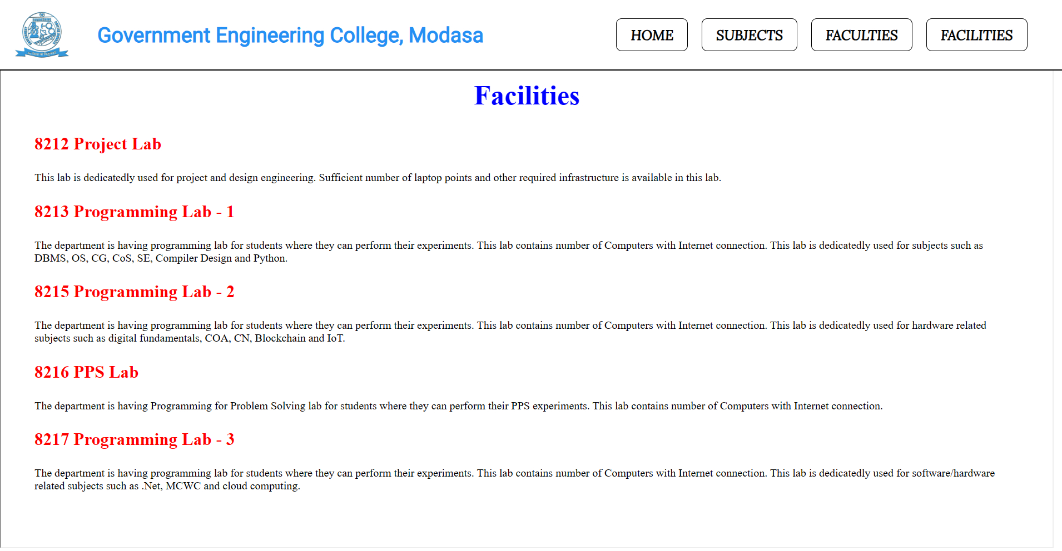

## **Quiz:**

1. **Explain External CSS.**

External CSS is a method of styling web pages in which the CSS code is stored in separate external files with a .css file extension. These CSS files are then linked to HTML documents using the <link> element. External CSS provides a way to centralize and reuse styles across multiple web pages, making it easier to maintain and update the styling of a website.

Here's how external CSS works:

1. Create a separate CSS file, e.g., styles.css, containing the CSS rules that define the styling for your web pages.
2. In the HTML document, use the <link> element within the <head> section to reference the external CSS file like this:

<!DOCTYPE html>

<html>

<head>

    <link rel="stylesheet" type="text/css" href="styles.css">

</head>

<body>

    <!-- Content goes here -->

</body>

</html>

1. **Compare Internal, Inline and External CSS.**

**Internal CSS:**

Placed within the <style> element in the <head> section of an HTML document.

Styles apply to the entire HTML document where they are embedded.

Suitable for single-page styling or small-scale projects.

**Inline CSS:**

Applied directly to individual HTML elements using the style attribute within the element's tag.

Styles apply only to the specific element they are applied to.

Useful for quick, specific style adjustments but can become hard to maintain.

**External CSS:**

CSS code is stored in separate external .css files.

Linked to HTML documents using the <link> element.

Styles can be reused across multiple web pages for consistent design.

Recommended for larger projects and easy maintenance.

1. **Which property is used to change the background color?**

The CSS property used to change the background color of an element is background-color. You can specify the background color using a color name, a hexadecimal color code, an RGB value, or other valid color representations.

1. **Which property is used to change the text color of the element?**

The CSS property used to change the text color of an element is color. You can specify the text color in the same way as the background color, using color names, hexadecimal color codes, RGB values, or other valid color representations.